Republic of Zambia

1. Description of the CNST and NPP construction project

On May 31, 2016 the Agreement between the Government of the Russian Federation and the Government of the Republic of Zambia on cooperation in the field of nuclear energy for peaceful purposes was concluded. The Agreement provides for cooperation between the parties in a wide range of areas of nuclear science and technology, including the design and construction of power and research reactors and particle accelerators, as well as fundamental and applied research in the field of nuclear energy for peaceful purposes, power, production of radioisotopes and their application in medicine and agriculture, education and training of national specialists for the Republic of Zambia.
On February 16, 2017 the Agreement between the Governments of the Russian Federation and the Republic of Zambia on the construction of the Center for Nuclear Science and Technology (CNST) was signed on the territory of the Republic of Zambia.
In 2017, the EPC-contract was signed between the Ministry of Higher Education of the Republic of Zambia and GSPI JSC for CNST construction with a research reactor of up to 10 MW (thermal). The NSTC is equipped with modern radiation facilities consisting of a multipurpose irradiation facility and a charged-particle accelerator. Multipurpose irradiation center includes a linear accelerator and a microbiology laboratory.
Zambia Vision 2030, developed in 2006, states that energy is one of the driving forces behind the country's economic development, as it affects a large part of economic and social activity.
The enhancement of human resources for scientific and energy industries is important for the implementation of the set tasks. For this purpose, cooperation between the Russian Federation and the Republic of Zambia is being developed in the area of training Zambian students in nuclear and related specialties. In 2021 the Russian Federation trained 71 Zambian graduates (under the quotas of the Russian Federation), 11 students from Zambia are graduating from Russian partner universities of the Rosatom State Corporation.
Students study at the following universities: 59 students study at the NRNU MEPhI, 1 student studies at Moscow Power Engineering Institute (hereinafter - MPEI), 2 students study at TPU, 1 student at Peter the Great St. Petersburg Polytechnic University (hereinafter - SPbPU), 2 students study at Moscow State University of Civil Engineering (hereinafter - MSUCE), 3 students study at UFU, 1 student studies at Saint-Petersburg State University of Architecture and Civil Engineering (hereinafter - SPSUACE). There are 4 quotas for the 2022/23 academic year for nuclear and related specialties. Selection tests shall be finished by December 25, 2021 (According to Rosatom State Corporation staffing information for the Republic of Zambia (as of November 2021).
Mechanisms for employment of Zambian graduates who studied under the quotas of the Ministry of Education and Science of the Russian Federation through the Rosatom State Corporation do not function on a systematic basis, not all graduates can find a job after graduation, even with a red diploma.
Under the contract for the assessment and development of nuclear infrastructure of the Republic of Zambia, signed on June 19, 2017 between the Government of the Republic of Zambia represented by the Ministry of Higher Education and Rusatom Service JSC, in 2018 the Russian party conducted assessment of the nuclear infrastructure. The assessment included consideration of the recruitment needs of key Zambia's NEP organizations in relation to the lifecycle of facilities (CNST and NPP). The negotiations for CNST project implementation had been suspended as of February 2022 due to serious epidemiological situation and outstanding funding issues for CNST project.

2. Key organizations of the nuclear infrastructure of Zambia
The national nuclear industry structure of the Republic of Zambia is divided into the following organizations:
- Ministry of Higher Education (MHE);
- ZAMATOM Agency (at the stage of formation);
- Radiation Protection Authority (hereinafter RPA).

The formation of key organizations of nuclear energy program in the Republic of Zambia has not been completed.
At the present, the Body responsible for the nuclear program and enhancement of human resources for the nuclear industry is the Interim Secretariat, which was established by the Ministry of Higher Education in January 2017 and became ZAMATOM in August 2018.
The Interim Secretariat includes 8 people from various ministries and organizations of the Republic of Zambia. ZAMATOM is nominally responsible for projects in the field of nuclear energy use, but the organization status has not been legitimized yet.

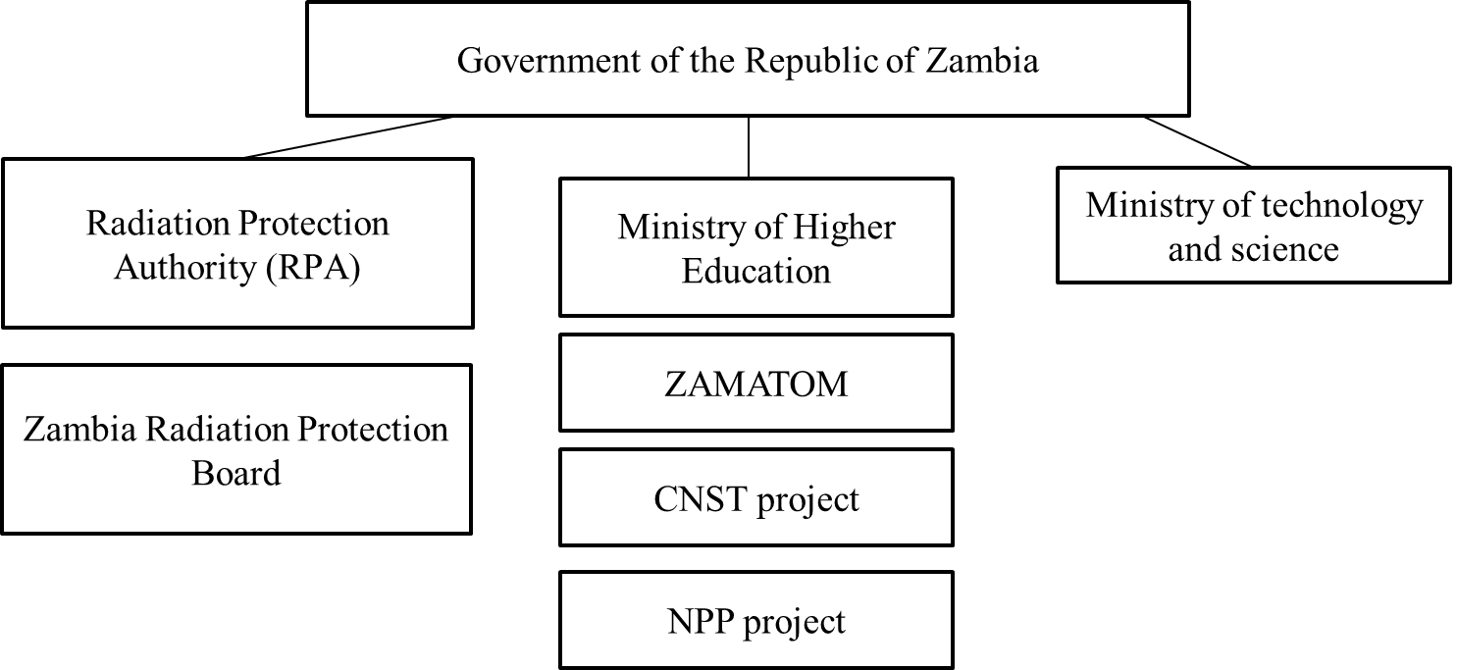
Fig. 18. Nuclear industry structure of the Republic of Zambia

2.1. Ministry of Higher Education of the Republic of Zambia
The Ministry of Higher Education was established by the Decree of the Government No. 836 dated 2016 for policy-making and regulation of university education, professional education and training. The Ministry is authorized to promote and apply science, technology, and innovation for social and economic development. The Ministry of Higher Education is subordinate to the Cabinet Ministers of the Republic of Zambia. The Ministry of Higher Education Permanent Secretary on 5th December, 2016 signed the cooperation agreement in training and skills development in the field of nuclear science’s at with the Government of Russian Federation and ROSATOM. The document is aimed at developing an integrated country of human resource plan for personnel for nuclear power plant.
Mission:
The Ministry wants to expand equal access to good quality, productive education and professional training. It strives to promote research and innovation in the field of science and technology to increase the commercialization and penetration of research and innovation products into the market.
Vision:
The Ministry of Higher Education focuses on making Zambia a prosperous middle-income country based on knowledge by 2030.
Head: Douglas Siakalima, Minister of Education.
Organizational structure of the Ministry:
- Department of Planning and Information;
- Department of Human Resource and Administration;
- Department of Vocational Education and Training;
- Department of Science, Technology and Innovation;
- Department of Finance.

Staffing level: there is no information on the official website.

2.2. Zambia Atomic Energy Agency (ZAMATOM)
The Cabinet Office is responsible for the creation of Zambia Atomic Energy Agency. The Agency acts as NEPIO, the owner/operator of CNST, the NPP project development office (organization performing nuclear power program). ZAMATOM was created in 2017 by the Ministry of Higher Education as the Interim Secretariat for Nuclear Science and Technology. As of February 2022, the status on ZAMATOM is not defined.
Mission:
The general purpose of the Atomic Energy Agency is to act as a special mechanism for coordinating all activities for the peaceful use of nuclear energy and to coordinate the construction of two major development facilities, namely:
a) The Center for Nuclear Science and Technology (CNST), including research reactor;
b) Nuclear power plant.
Head: not defined, previously Dr. Roland Msiska.
Organizational structure: not created.
According to preliminary data, the Atomic Energy Agency is divided into 3 functional units:
• NEPIO section (the Interim Secretariat);
• CNST unit;
• NPP unit.
The total staffing level of the Organization is not defined.
Functions of the Atomic Energy Agency:
- development of the national strategy in the field of nuclear energy use, legal and regulatory framework;
- conducting an economic assessment;
- determination of financial model for NPP construction;
- determination of policy in the field of NFC.

2.3. Radiation Protection Authority (RPA) of the Republic of Zambia

Radiation Protection Authority (RPA) is a statutory body under the Ministry of Technology and Science established in accordance with an Act of parliament No.16 of 2005 and the Law on Amendment No. 19 of 2011.
The Board: brigadier general Dr. Adrian Maleya.
Mission: To protect the people and the environment from the harmful effects of radiation.
Total staff number: 60 workers
Organization structure of RPA:
- Technical Services Department. This department is responsible for providing radiation protection services and technical support to facilitate regulatory function of the Authority.
- The Nuclear and Radiation Safety Department. This department is responsible for ensuring that all facilities licensed comply with the obligations of the law and all safety requirements are met.
- The Finance Department. This department is responsible for all financial management and accounting functions.
- The Human Resource and Administration Department. This department is responsible for personnel recruitment and development.
It is supposed that if Zambia nuclear program to build the CNST and NPP is implemented, it will require the further development of a regulatory body of at least additional 100 people.
Vacancies Organizations are published on the official RPA website.
RPA functions are to provide for the protection of the public, personnel and environment from hazards arising from the use of nuclear plants or materials capable of producing ionizing radiation.

Table 9. Potential employers of the Republic of Zambia: universities and organizations.
No. | Name of the organization
1 | Ministry of Health
2 | Zambia Medicines Regulatory Authority
3 | Medical Stores Limited and its regional hubs
4 | Cancer Diseases Hospital, CDH
5 | District hospitals and clinics
6 | Public Health Committee
7 | Social development and services
8 | Churches Health Association of Zambia, CHAZ
9 | University of Zambia - School of Public Health
10 | Zambia Medical Association, ZMA
11 | Health Professional Council of Zambia, HPCZ
12 | Zambia National Public Health Institute
13 | Ministry of Technology and Science of the Republic of Zambia

3. Qualification requirements

Qualification requirements for employees of nuclear infrastructure organizations
The RPA function is to confirm qualifications of personnel responsible for safe operation of prescribed activities and facilities in accordance with Article 11 of the Radiation Protection Act, 2017. In addition, RPA establishes qualification requirements for supervisors in accordance with Article 68 of this law and provides a specialized training programme to ensure a high-quality level of supervisor competence.

