. The Plurinational State of Bolivia

Description of the CNTRD construction project
Law No. 650 adopted on January 15, 2015 approved the Patriotic program for the national energy development until 2025, which determined the need to achieve scientific and technological sovereignty in Bolivia. The Program was followed by the decision (Supreme Decree No. 2654 dated January 20, 2016) to create and develop the Bolivian nuclear program in order to establish a scientific and technological culture in the country with peaceful applications of nuclear technology, including science and technology, health, agriculture, as well as education and human resource development. Implementation of the Bolivian nuclear program has been declared a national priority, and is supported by the central government, autonomous territorial entities and private institutions.
Significant steps made toward the development of the national nuclear program were the agreements between the government of the Russian Federation and the government of the Plurinational State of Bolivia.
On October 8, 2015, a Memorandum of understanding on cooperation in the peaceful uses of atomic energy was signed between the Rosatom State Corporation and the Ministry of Hydrocarbons and Energy of the Plurinational State of Bolivia. In December 2015, the Government of the Russian Federation and the Government of the Plurinational State of Bolivia signed an Agreement on cooperation in the field of the use of atomic energy for peaceful purposes. On March 6, 2016 the Government of the Russian Federation and the Government of the Plurinational State of Bolivia signed an Agreement on cooperation in the construction of the Center for Nuclear Technology Research and Development on the territory of the Plurinational State of Bolivia The CNTRD construction project is implemented by the Bolivian Nuclear Energy Agency (ABEN) in cooperation with GSPI JSC (part of the management perimeter of Rusatom Overseas JSC).
On July 11, 2019, a Memorandum of understanding was signed in Moscow between the Federal Environmental, Industrial and Nuclear Supervision Service (Rostechnadzor) and the Bolivian Electricity and Nuclear Technology Regulatory Authority on cooperation in the field of nuclear and radiation safety regulation in the peaceful use of atomic energy.
CNTRD will produce radiopharmaceuticals enabling more than 5,000 procedures per year to diagnose and treat oncology diseases. In addition, the center will carry out radiation treatment of agricultural products, which will improve their quality, extend their shelf life, and significantly increase exports. The research reactor and laboratories will enable cutting-edge research and training of highly qualified personnel for the Bolivian nuclear industry.
Cooperation is developing through the training of Bolivian students in nuclear and related specialties in Russian universities. As for 2022, 32 Bolivian students study under the quotas offered by the Rosatom State Corporation. The students are studying at NRNU MEPhI (22 students), MIPT (2 students), MIREA (1 student), Peter the Great St. Petersburg Polytechnic University (2 students), St. Petersburg State University of Architecture and Civil Engineering (3 students), St. Petersburg Mining University (1 student), Voronezh State University (1 student). For the academic year 2022/23, five quotas are planned for Bolivian students to study nuclear and related specialties at supporting universities of the Rosatom State Corporation. A joint educational program of the bachelor's degree level on “Nuclear technology” between NRNU MEPhI and the Higher University of San Andrés is being implemented. In academic year 2020/2021, 19 students from Bolivia attended educational modules of NRNU MEPhI.
Mechanisms for employment of Bolivian graduates who studied under the quotas of the Ministry of Education and Science of the Russian Federation through Rosatom State Corporation do not function on a systematic basis, not all graduates can find a job after graduation, even possessing diploma with honors.

2. Key organizations of the nuclear infrastructure of Bolivia

The nuclear industry of the Plurinational State of Bolivia is constituted by the following organizations:

- Ministry of Hydrocarbons and Energy;
- Bolivian Nuclear Energy Agency (ABEN);
- Electricity and Nuclear Technology Supervision Authority (AETN).

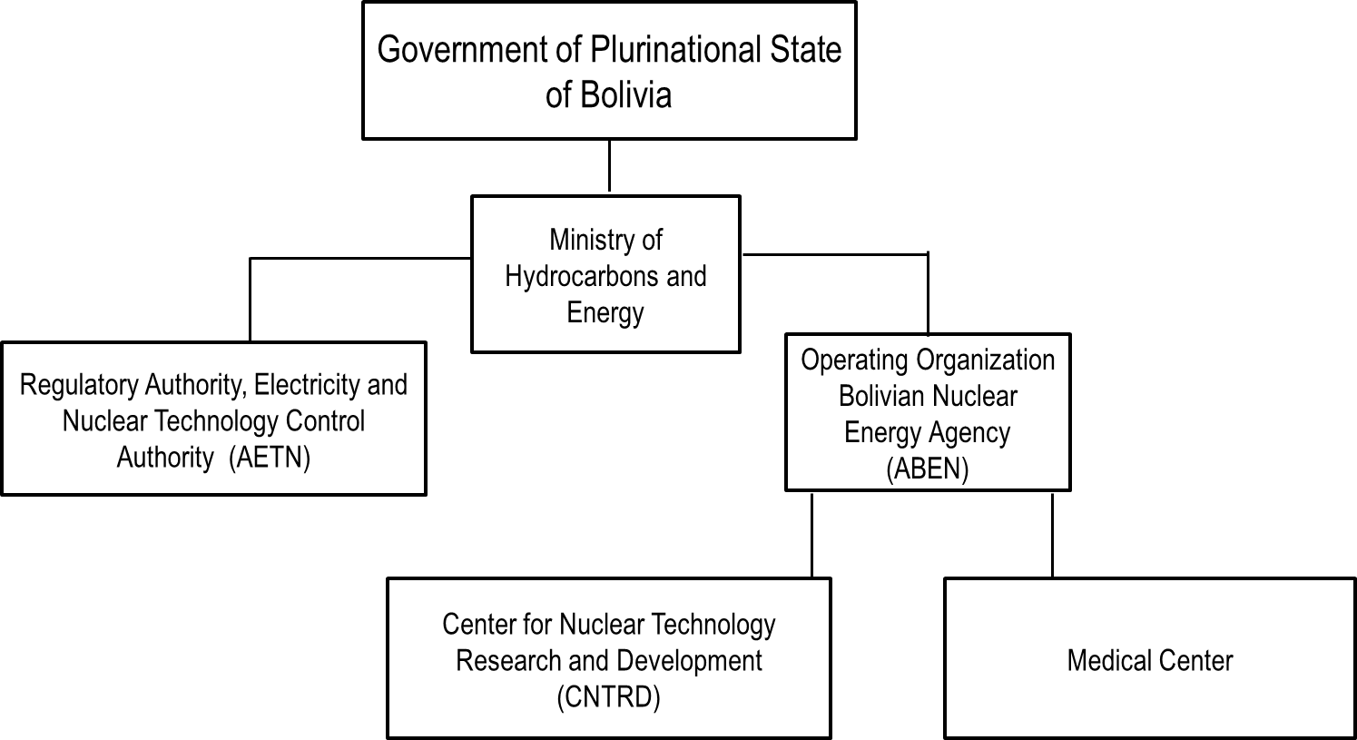
Fig. 14 Structure of Bolivia's nuclear industry

2.1. Ministry of Hydrocarbons and Energy
Supreme Decree No. 29894 of February 7, 2009 approved the organizational structure of the Ministry of Hydrocarbons and Energy. Responsibility for the development and coordination of Bolivian energy policies has been defined within the framework of the Political Constitution of the State. The Ministry is responsible for coordination of all key organizations related to the nuclear industry in Bolivia.
The Ministry is composed of the Vice-Ministry of Electricity and Alternative Energies (electricity sector) and the Vice-Ministry of High Energy Technologies (lithium projects, nuclear technologies).
Vision
The Ministry of Hydrocarbons and Energy develops and implements policy as the fundamental basis for economic and social development of the Bolivian population, developing the country as the energy center of the region.
Mission:
Comprehensive development of the energy sector that contributes to the well-being of Bolivians on the basis of equality and sustainability in harmony with the Mother Earth.
Head: Franklin Molina Ortiz who has been the Minister since November 9, 2020.
Total number of staff: 350 employees according to the web-site.

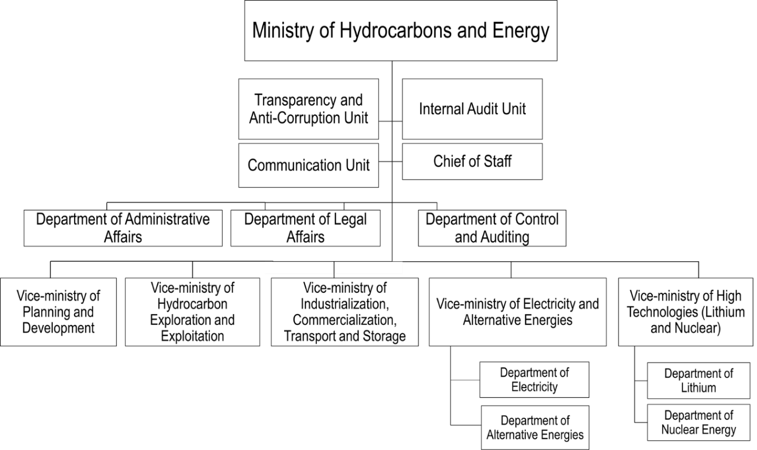
Fig. 15. Organizational structure of the Ministry of Hydrocarbons and Energy

2.2. Bolivian Nuclear Energy Agency (ABEN)
By issuing the Supreme Decree No. 2697 on March 9, 2016, the Government of the Plurinational State of Bolivia established the Bolivian Nuclear Energy Agency (ABEN) as a decentralized public institution subordinate to the Ministry of Hydrocarbons and Energy with legal existence and its own property, autonomy of administrative, technical, legal, economic and financial management.
Mission:
Develop research and provide services for peaceful applications of nuclear technology.
Vision
To be a leading national public institution in the development of nuclear technology through research and development in the field of peaceful application of nuclear energy for the benefit of population, industry and other sectors of Bolivia.
Head: Hortensia Jiménez, General Executive Director.
Total number of staff is not specified on the web-site; according to information received through unofficial communication, there are currently 90 employees.
Information about vacancies is not available at the Organization's website.

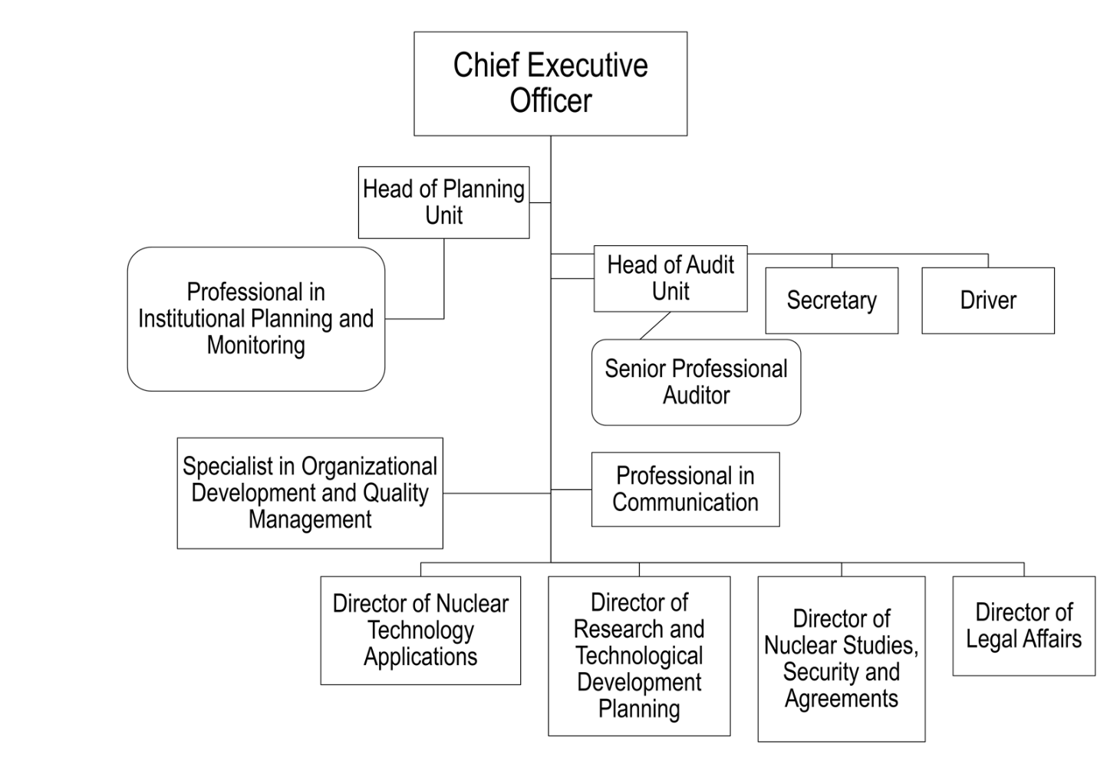
Fig. 16. Organizational chart of ABEN
Functions of ABEN:
- implementation of nuclear technology policies;
- development and proposition of plans and programs regarding nuclear technologies;
- supply and/or distribution of goods related to nuclear technologies.
- development and provision of services in the field of nuclear technology;
- development of national research in the field of nuclear science and technology for peaceful purposes;
- operation of nuclear facilities under the Bolivian nuclear program;
- use of state property and protection of radioactive materials contained in irradiated fuel elements and generated on the Bolivian territory;
- construction and operation of the Center for Nuclear Technology Research and Development (CNTRD) in El Alto;
- fulfillment of other functions specified in applicable laws.

2.3. Electricity and Nuclear Technology Supervision Authority of the Plurinational State of Bolivia (AETN)
The Electricity and Nuclear Technology Supervision Authority (AETN) has been fulfilling functions of a nuclear regulatory authority since May 2019 based on the Supreme Decree No. 3892.
Vision:
AETN is committed to ensure efficient, fair, and safe development of the electricity and nuclear technology industries.
Mission
We monitor, supervise and control activities related to electricity generation and nuclear technologies, guaranteeing that the interests and rights of consumers are met and ensured, and creating conditions for the effective, sustainable and safe development of these industries.
Head: Eusebio Lucio Aruquipa Fernández.
Total number of staff is not specified on the website. According to the information received through routine communication with the AETN officials, the staff of AETN consists of 300 people, and the Nuclear Technology Directorate, which is part of it, has 15 employees.
Functions of AETN
According to Law No. 1205 on “Peaceful application of nuclear technology” dated August 1, 2019, AETN through the Nuclear Technology Directorate controls and supervises nuclear activities in terms of their compliance with nuclear and radiation safety, security and IAEA safeguards for radiation and nuclear facilities to prevent harmful effects of ionizing radiation on people and the environment.
АЕТН functions include:
- development of rules and provisions;
- licensing of radiation and nuclear facilities;
- evaluation of quality assurance programs and environmental radiological monitoring programs;
- performance of examinations, supervision, technical visits, inspections, and tests of radiation and nuclear facilities;
- performance of inspections and examinations related to security and compliance with safeguards;
- assessment and licensing of radiation and nuclear facilities;
- issuance of licenses and permits for the import, export, return, use, transportation, and storage of radioactive materials;
- issuance of licenses and permits for the import, export and use of equipment generating ionizing radiation;
- assessment and licensing of radioactive waste temporary storage;
- participation in technical assistance and international cooperation conventions;
- implementation of research projects independently or in cooperation with other regulatory agencies or research centers.

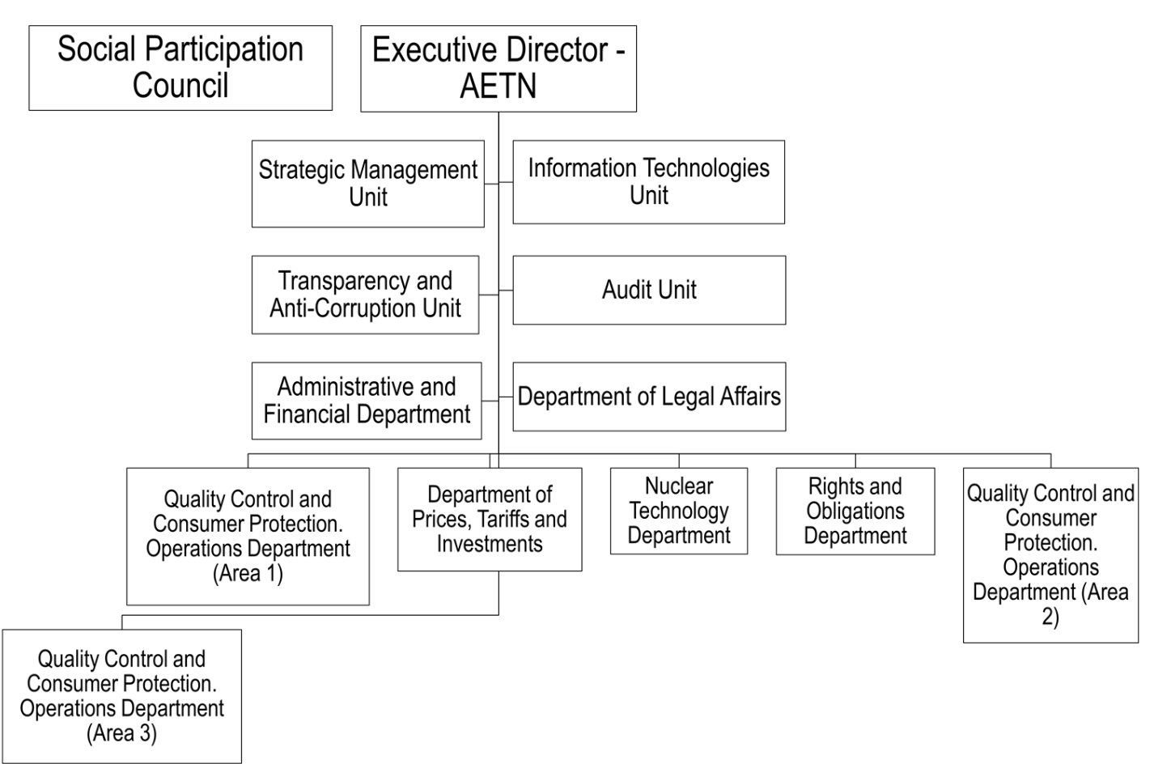

Fig. 17. Organizational structure of AETN.

3. Qualification requirements

Qualification requirements for employees of nuclear infrastructure organizations

According to Law No. 2027 "Statute of the civil servant" and Law No. 2104 amending the Statute of the Civil Servant, employees of the Ministry of Hydrocarbons and Energy shall have a degree in social, economic, engineering and related fields. Candidates shall:
- have a professional certification diploma;
- hold Bolivian citizenship;
- have a certificate of military service;
- be on the electoral roll.
ABEN is currently working on Personnel Regulations and requirements for positions and job descriptions.

