**Instruction**

**How to make the Medical checkup for fingerprints (дактилоскопия)**

Hospital address: улица Красноармейская 68, phone number: **60-77-78**

Working hours: 9.00 till 16.00

It is not far from your dormitory, just go straight along Krasnoarmeiskaya street on foot.

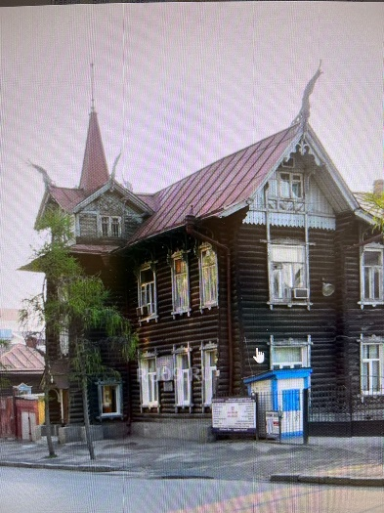

The hospital is located in the wooden house.

1. Come inside the hospital;
2. Put on plastic shoes protectors (чистые бахилы);
3. Leave your jacket at a coat room (гардероб);
4. Go to reception desk (регистратура) say: «**Мне нужно пройти мед осмотр для дактилоскопии»;**
5. Submit your **passport, translation of your passport** into Russian with notary stamp, **chest X-ray test** (if you had it before in Tomsk) and **money 4200 RUB** (hospital also accepts a bankcard).
6. Administrator will give you a paper with numbers of offices (кабинет) you must visit.
7. **Visit office number 9 at the end**!

|  |  |  |  |
| --- | --- | --- | --- |
| Doctor | Place, office number (№ кабинета) | Time | Doctors marks and signatures |
| **Addiction psychiatrist** (Психиатр-нарколог) | Кабинет 10, 1 этаж  Office 10, 1 floor |  |  |
| **Tuberculosis specialist**  You visit at the end!  (Фтизиатр) | Кабинет 9, 1 этаж  Office 9, 1 floor |  |  |
| **Infection disease doctor** (Инфекционист) | Кабинет 11, 2 этаж  Office 11, 2 floor |  |  |
| **Urine test** for strong medicine or drugs  (Моча на ХТИ) | Кабинет 10, 1 этаж  Office 10, 1 floor |  | At the office № 10 doctor will give you a container, you need to go to toilet and collect your urine, return it back to the office №10 |
| **Chest X-ray test**  Флюорография | Кабинет 3, 1 этаж  Office 3, 1 floor |  | If you already have made it for dormitory, take the result of chest X-ray test (флюорография) with you. You do not need to do it again, and you pay 360 rub less. |
| **Blood test for HIV**  Кровь на ВИЧ | Кабинет 6, 1 этаж  Office 6, 1 floor |  |  |
| **Blood test for syphilis**  Кровь на сифилис | Кабинет 6, 1 этаж  Office 6, 1 floor |  |  |

Medical conclusion will be ready within 3-4 days after the medical checkup. You can take it at the office (кабинет) № 2, the same hospital.

Take the medical conclusion, come to the building TPU № 8, office 330 to make a copy and make an appointment for fingerprints(дактилоскопия).

You can apply for compensation for fingerprint’s medical checkup at the office 330, building TPU № 8 checkup (ONLY if you have a scholarship). Keep all your receipts and medical agreement from medical checkup.

**This is the document about obligatory Government dactyloscopy (fingerprints)**

**of foreign citizens in the Russian Federation**

