The Republic of Uzbekistan

1 Description of the NPP construction project in the Republic of Uzbekistan

According to the Agreements concluded by the Governments of the Russian Federation and the Republic of Uzbekistan on cooperation in the field of peaceful use of atomic energy dated December 29, 2017 and on cooperation in construction of nuclear power plant at the territory of the Republic of Uzbekistan dated September 7, 2018, the Parties maintain cooperation in the field of education and training of operational personnel for the first nuclear power plant in Uzbekistan, as well as in the field of education and training of personnel for nuclear industry as a whole and adjacent areas. Negotiations on conclusion of EPC-Contract for NPP construction are currently ongoing.
According to the National Energy Programme of Uzbekistan and the Agreements, it is planned to construct NPP with two VVER-1200 power units, 1.2 GW capacity each (total capacity is 2.4 GW), and the NPP will be located (as per preliminary considerations) near Tuzkan lake in the Jizzakh region.
A Strategy of human resources development for Nuclear Energy Programme of the Republic of Uzbekistan was adopted by the Decree No. 4492 of the President of the Republic of Uzbekistan dated 16.10.2019. The human resources strategy is adopted in pursuance of the Decree No. 4165 of the President of the Republic of Uzbekistan dated February 7, 2019 “On approval of the Concept of nuclear industry development in the Republic of Uzbekistan for 2019-2029”, as well as to ensure timely and comprehensive implementation of the nuclear energy programme of the Republic of Uzbekistan by qualified personnel meeting the requirements of the safe atomic energy use.
The main areas of the Strategy of human resources development for Nuclear Energy Programme of the Republic of Uzbekistan:
- improving regulatory and legislation framework;
- forming state order for personnel training;
- developing activities of MEPhI branch in Tashkent;
- developing educational institutions;
- training NPP personnel;
- training regulatory body personnel;
- training state body specialists;
- training academic staff and scientific workers;
- creating employee pool and ensuring continuity of critical positions;
- developing international cooperation.
The Agreements on cooperation in the field of human resources development concluded by Russia and Uzbekistan:
      - Memorandum of Understanding between the Academy of Sciences, UZATOM and Rosatom State Corporation on cooperation in the field of education and advanced training in nuclear industry was signed on October 19, 2018, with MEPhI branch opening in Tashkent. The Rosatom Technical Academy and the National Agency for Nuclear Power in Uzbekistan Uzatom signed an Agreement on personnel training for nuclear industry.
- On April 16, 2019, a Russian-Uzbek memorandum on cooperation in training personnel for the nuclear industry of the Republic of Uzbekistan was signed at the site of the XI International Forum “ATOMEXPO-2019” in Sochi.
- On July 3, 2018, as part of the International Seminar “Personnel Training for the Nuclear Industry: International Cooperation in Nuclear Education”, a Cooperation Agreement was signed between the “Rosatom Technical Academy” (Russia) and the Tashkent Chemical-Technological Institute (Uzbekistan). Through this agreement, a basis has been established for joint activities in personnel training and research in nuclear science and technology, aimed at creating a sustainable system for the peaceful use of nuclear energy and the development of infrastructure in the Republic of Uzbekistan.
IAEA INIR - Phase 2 mission took place in Uzbekistan over the period from May 24 until June 3, 2021 on integrated assessment of the Uzbekistan nuclear infrastructure condition, two of the five best practices reflected in the IAEA report are related to the human resources development for national nuclear programme:
- a local department of the university has been established in Uzbekistan to ensure the recruitment of specialists for the country's nuclear energy programme; the academic programme is currently being coordinated with the curricula of other universities;
- UZATOM has developed a system to identify talented students and qualified professionals and managers working in other sectors, to receive mentoring and training, as well as the possibility of quick recruitment for important positions in key organizations.
IAEA experts noted in their recommendations the importance of having competent personnel in the State Committee of Industrial Safety of the Republic of Uzbekistan to carry out the functions of a supervisory body.
Uzbek students studying at Russian universities in nuclear and related specialties do not experience difficulties in finding employment in key organizations of the nuclear industry of Uzbekistan.

2 Key organizations of the nuclear infrastructure of the Republic of Uzbekistan

RUz NEP structure includes:
- Ministry of Energy of the Republic of Uzbekistan;
- UZATOM Agency (including the Directorate for NPP Construction);
- State Committee of Industrial Safety of the Republic of Uzbekistan.

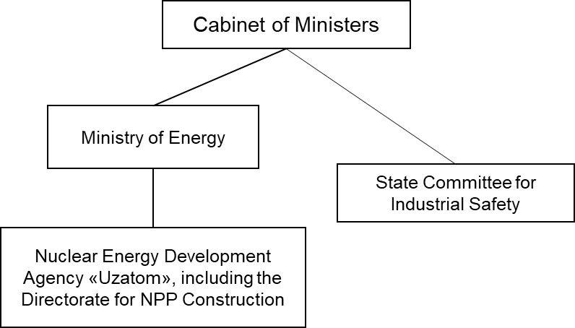

Fig. 9. RUz nuclear industry structure

2.1. Ministry of Energy of the Republic of Uzbekistan
The Ministry of Energy of the Republic of Uzbekistan was established by the President’s Decree No. 5646 of 01.02.2019 “On measures to Radically Improve the Management System of the Fuel and Energy Industry of the Republic of Uzbekistan”.
According to the Law on the Peaceful Use of Atomic Energy No. 565 of September 9, 2019, the Ministry of Energy of the Republic of Uzbekistan “organizes a system of training, retraining and advanced training of personnel required for the operation of nuclear facilities, as well as abroad”.
The functions of the Ministry, in accordance with the Law of the Republic of Uzbekistan “On the Peaceful Use of Atomic Energy”, include the following:
- implementing a unified energy policy aimed at ensuring the country's energy security and meeting the growing need for power resources for sectors of the economy and the population of the country;
- differentiating functions of state regulation and economic activity in the field of energy, improving the legal and institutional framework of social and public-private partnerships, developing clear market mechanisms for implementing tariff policies and promoting the principles of a healthy competitive environment based on it;
- creating conditions for active attraction of investments, especially foreign direct investment, in the construction of infrastructure facilities, as well as modernization, technical and process re-equipment of industry enterprises;
- implementing state policy in energy saving and reduction of energy intensity of economy, stimulation of active introduction of advanced resource and energy saving technologies in sectors of economy and domestic sector, wide development of alternative power sources;
- introducing modern tools for automation of processes, accounting systems for production, supply and consumption of power resources at nuclear industry enterprises;
- optimizing the system for management of industry enterprises, their structures and subdivisions, introducing modern methods for organization of work and target indicators (quality management, indicative planning) aimed at achieving specific results.

Head: Alisher Sultanov, Minister of Energy of the Republic of Uzbekistan.
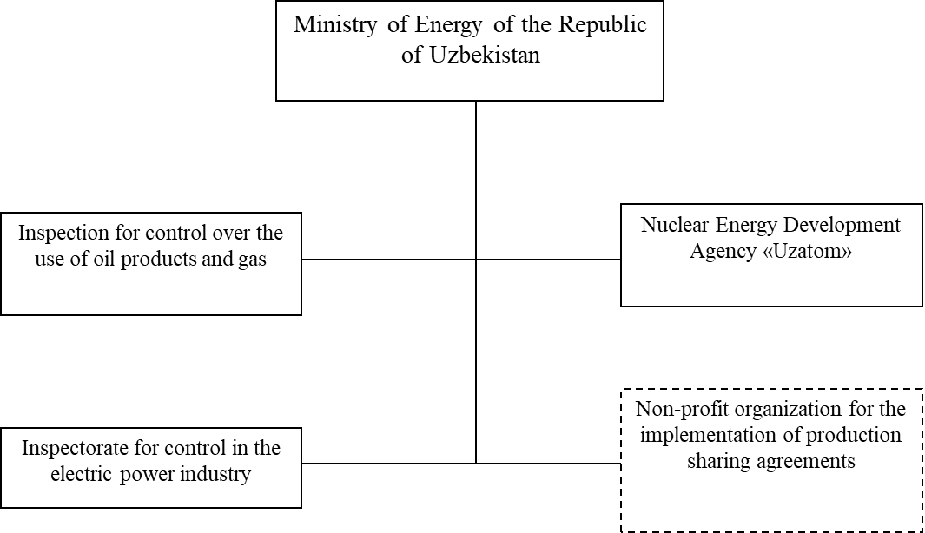
Fig. 10. Top-level organizational structure of the Ministry

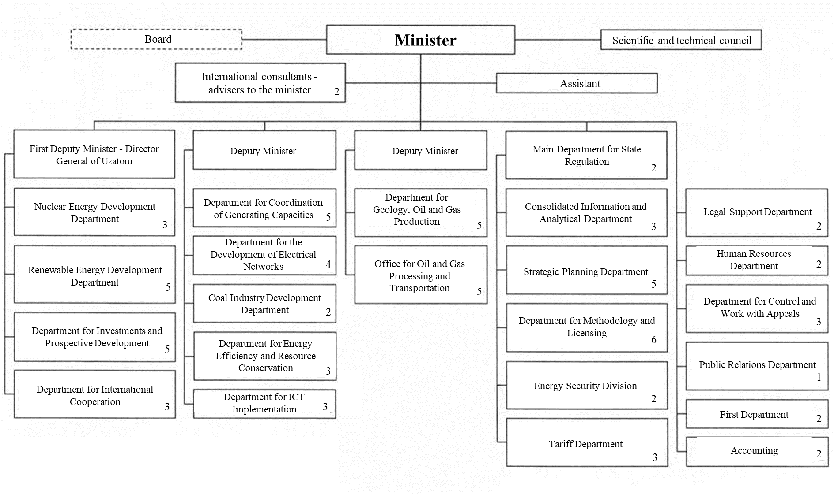
Fig. 11. Structure of the central office of the Ministry of Energy of the Republic of Uzbekistan

Total number of staff: the maximum total number of management personnel - 80 people.
Information about vacancies is published regularly on the Ministry’s website.

Table 7. List of vacancies of the Ministry of Energy of the Republic of Uzbekistan as of February 15, 2022:
No. | Structural subdivision name | Position name
1. | Management | Deputy Minister
2. | Department for Electric Mains Development | Chief Specialist
3. | Department of Geology, Oil and Gas Production | Deputy Head
4. | Department of Geology, Oil and Gas Production | Chief Specialist
5. | Oil and Gas Processing Department | Chief Specialist
6. | Methodology Department | Head of Directorate
7. | Methodology Department | Chief Specialist
8. | Judicial Support Department | Chief Specialist

Requirements for candidates applying for open positions in the Ministry of Energy of the Republic of Uzbekistan:

1. Citizens of the Republic of Uzbekistan irrespective of their sex, social background, property and official position are eligible for employment in the central office of the Ministry of Energy of the Republic of Uzbekistan. The following is evaluated to ensure completion of tasks assigned to the Ministry: professional skills, as well as business, personal and moral qualities, level of education, state of health.
2. Applicants for the positions of specialists in the central office of the Ministry of Energy shall have a degree of higher education in the field and no less than five years' professional experience in his or her area of specialization.

3.2.2. Agency for the Development of Nuclear Energy (UZATOM)
Art. 2 of the Decree of the President of the Republic of Uzbekistan No. 5484 dated July 19, 2018 "On measures for the development of nuclear energy in the Republic of Uzbekistan" defines the main objectives and areas of the “Uzatom” Agency's activity, and Art. 1 establishes that “Uzatom” is responsible for the development and implementation of a unified state policy and strategic areas of focus in the nuclear energy development and use.
Resolution of the Cabinet of Ministers of the Republic of Uzbekistan No. 653 dated August 13, 2018 approved the Regulation "On the Agency for the Development of Nuclear Energy under the Cabinet of Ministers of the Republic of Uzbekistan".
Head: Mirzamakhmudov Zhurabek.
Total number of staff: indicated on the Organization's official website, includes 48 employees.
Information about vacancies is available on the Organization's website. The staffing table is incomplete.
Main functions of UZATOM according to Art. 2 of the Regulation "On the Agency for Development of Nuclear Energy under the Cabinet of Ministers of the Republic of Uzbekistan”:
- elaboration of proposals on priority areas of the state policy in the field of peaceful use of nuclear energy, including development of regulatory legal acts;
- elaboration and implementation of state nuclear energy development programs in the Republic of Uzbekistan, attraction of investments, including foreign ones, for implementation of nuclear energy projects;
- conclusion of agreements and contracts on design, construction and operation of nuclear facilities introducing modern technologies and equipment that meet international industrial and environmental safety requirements;
- improvement of the radiation and nuclear safety system in the Republic's facilities and development of an action plan for the prevention of nuclear accidents and radiation emergencies together with other ministries and departments;
- ensuring non-proliferation of nuclear materials and technologies, radioactive materials, implementation of measures for ensuring physical protection and nuclear and radiation safety;
- organization of a training, retraining and advanced training system, including one for leading foreign institutes;
- international cooperation and interaction with the International Atomic Energy Agency, etc.
Organizational structure of the “Uzatom” Agency
Appendix No. 1 to the Decree of the President of the Republic of Uzbekistan No. 3870 dated July 19, 2019 approved the structure of the "Uzatom" Agency and the Organization's staffing table.
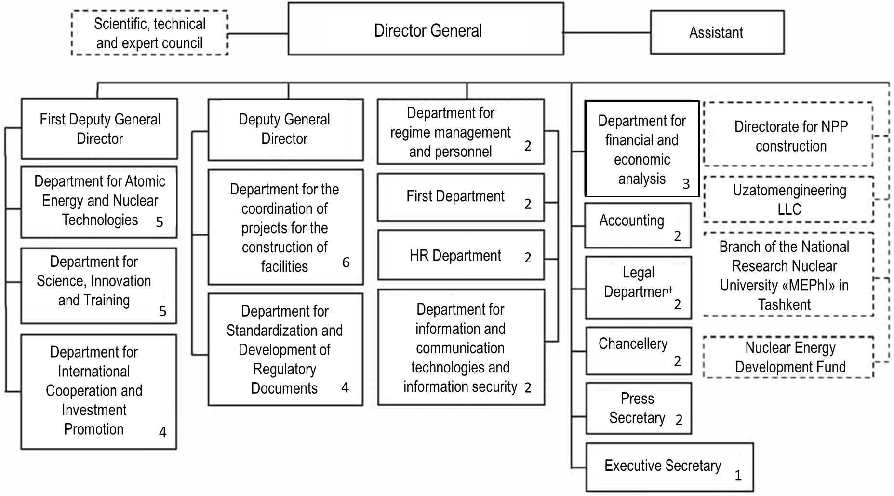
Fig. 12. Organizational structure of the “Uzatom” Agency

In accordance with the Decree of the President of the Republic of Uzbekistan No. 5484 dated 19.07.2018 "On measures for the development of nuclear power industry in the Republic of Uzbekistan”, the "Uzatom” Agency carries out "organization of a training, retraining and advanced training system, including one for leading foreign institutes".

Directorate for NPP Construction
The “Uzatom” Agency established the Directorate for NPP Construction by Resolution No. 1 dated February 21, 2019.
Total number of staff: not available at the official website of UZATOM.
Vacancies in the Directorate for NPP Construction are available at UZATOM website. As of 22.02.2022, there are five vacancies in the Directorate for NPP Construction.

Main functions of the Directorate for NPP Construction:
- organization and performance of engineering and survey works aimed at NPP siting;
- organization of design and estimate documentation development for NPP facilities and its external infrastructure, and approval of the documentation by authorized expert bodies;
- organization and coordination of contracted construction and installation works and other activities at the NPP facilities and external infrastructure upon agreement with the “Uzatom” Agency;
- development of technical assignments and documentation on procurement of equipment, works and services within the framework of the project on construction of NPP and its external infrastructure in the territory of the Republic of Uzbekistan;
- participation in examination, analysis and preparation of proposals on the selection of design solutions, process flow diagram, safety systems, physical protection, main and auxiliary equipment;
- supervision over the quality of work performed under the project, and its acceptance in terms of nuclear technology, geodesy, geological, seismotectonic and environmental work;
- participation in the development of regulatory documents in the field of atomic energy use, nuclear and radiation safety assurance, handling of nuclear materials and radioactive substances;
- coordination of work with foreign consultants involved in the project implementation.

2.3. State Committee on Industrial Safety of the Republic of Uzbekistan, Goskomprombez
The State Committee on Industrial Safety of the Republic of Uzbekistan (Goskomprombez) was formed in accordance with the Decree of the President of the Republic of Uzbekistan No. 5594 dated 12.12.2018 "On measures for radical improvement of the state administration and supervision system in the areas of industrial, radiation and nuclear safety" and is defined as "the authorized regulatory body responsible for the implementation of a unified state policy and control in the field of ensuring radiation and nuclear safety at nuclear power and nuclear technology facilities, as well as in the field of industrial safety at hazardous production facilities".
Organizational structure of the Radiation and Nuclear Safety Department of Goskomprombez and its staffing table developed for several years were approved by the Decree of the President No. 4058, which stipulates employment of 40 new employees from 2024 to 2028, reaching a total of 71 people.
Head: Gulyamov Bakhtiyort, chairman.
Number of staff in the Radiation and Nuclear Safety Department of Goskomprombez: 71 people.
Information about job vacancies is not available on the Organization's website.

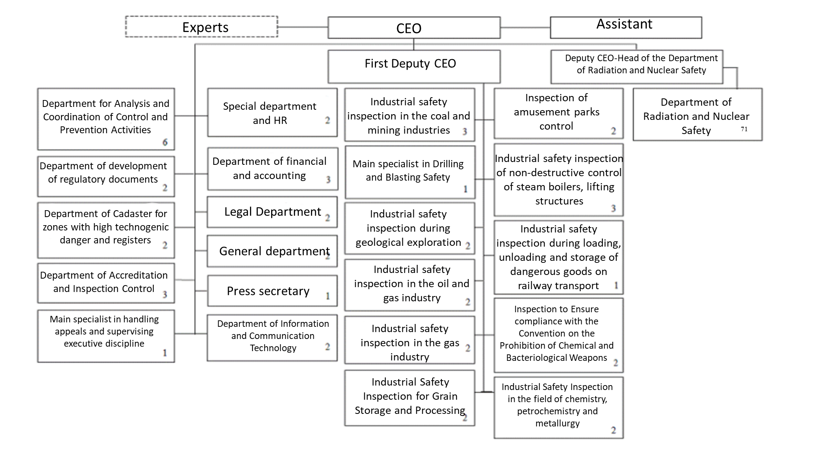Fig. 13. Structure of the Central Office of the State Committee on Industrial Safety of the Republic of Uzbekistan

Main functions of Goskomprombez
Resolution of the Cabinet of Ministers of the Republic of Uzbekistan No. 75 dated 01.02.2019 approved the Regulation on the State Committee on Industrial Safety of the Republic of Uzbekistan. Law of the Republic of Uzbekistan dated 09.09.2019 No. 565 “On the use of atomic energy” defines the main nuclear regulation issues. Regulation on Goskomprombez defines the regulatory body's functions:
- implementation of state policy and regulation in the field of radiation and nuclear safety assurance at nuclear power facilities and nuclear technologies, in the field of industrial safety assurance at hazardous production facilities;
- state surveillance and supervision over compliance of legal entities and individuals with requirements of legislation and regulatory documents in the field of technical regulation of industrial, radiation and nuclear safety issues, in the operation of amusement parks, as well as the use and protection of subsoil hydrocarbons;
- licensing in the field of nuclear energy and nuclear technologies, coordination of state supervision bodies activities in the field of industrial, radiation and nuclear safety;
- improvement of the industrial safety expertise and accreditation system, as well as organization of safety expertise of facilities associated with the nuclear energy use;
- development and adoption of regulatory legal and regulatory documents in the field of technical regulation industrial, radiation and nuclear safety issues in accordance with the established procedure;
- international cooperation with international and foreign organizations, and fulfillment of the Republic of Uzbekistan's obligations under international treaties relevant to the committee's activity area;
- professional advancement of specialists carrying out activities in the area of industrial, radiation and nuclear safety, taking into account the dynamic development of technologies and equipment in these areas.

2.4. Potential second priority employers

Potential second priority employers in the nuclear industry of the Republic of Uzbekistan also include universities and research centers:
- National University of Uzbekistan;
- Tashkent State Technical University named after Islam Karimov;
- Tashkent branch of the National Research Nuclear University MEPhI;
- Samarkand State University;
- Academy of Sciences of the Republic of Uzbekistan.
In accordance with the Decree of the President of the Republic of Uzbekistan dated July 19, 2018 No. 5484 "On measures for the development of nuclear energy in the Republic of Uzbekistan", new master degree programs, such as "Physics of atomic nuclei and elementary particles, accelerators”, "Nuclear physics and nuclear technology (according to their field of application)” were introduced in the National University of Uzbekistan named after Mirzo Ulugbek, and the program "Physics of atomic nuclei and elementary particles, accelerators” was also introduced in the Samarkand State University.
Table 8. Universities and research centers of the Republic of Uzbekistan.
No. | Organization | General information | Job vacancies
1 | National University of Uzbekistan named after Mirzo Ulugbek | The university was founded in 1918.  The physics faculty offers the following programs:  - Theoretical Physics  - Nuclear Physics.  - Semiconductor and Polymer Physics  - Photonics  - General Physics  - Astronomy and Astrophysics  As of February 2022, 35 students are enrolled in the nuclear power programs. | Information about current vacancies is available at the University's website.
2 | Tashkent State Technical University named after Islam Karimov | The Faculty of Energy offers the following programs:  - power plants, networks and systems;  - power supply;  - hydraulics and hydraulic power;  - thermal power;  - electromechanics and electrical technologies;  - electrical machines;  - alternative power sources;  - control and monitoring systems in the power industry;  - electrical engineering.  As of February 2022, 120 students are enrolled in the nuclear power programs. | There is no information on the official website.
3 | Tashkent branch of the National Research Nuclear University MEPhI | Founded in 2019.  The Nuclear Physics and Thermal Physics Faculty offers the following programs:  - Nuclear Power Engineering Department;  - Nuclear Physics Department.  The Electric and Thermal Power Engineering Faculty offers the following programs:  - automatics department;  - electrical equipment department.  As of February 2022, 221 students are enrolled in the nuclear power programs. | The job openings are given on the web-site:  Qualification requirements for the teaching staff:  - Assistant: higher professional education and at least one year of work experience in an educational institution; if the applicant holds a postgraduate degree (PhD, a degree after finishing residency training or postgraduate military studies) or is a candidate of sciences, work experience is not required.  - Assistant professor: higher professional education and at least three years’ experience of academic work; if the applicant holds a degree of candidate of sciences, the academic work experience shall be at least one year.  - Associate professor: higher professional education, degree of a candidate (doctor) of sciences and at least three years’ experience in academic work, or academic rank of associate professor (senior research officer).  - Professor: higher professional education, degree of a doctor of sciences and at least five years’ experience of academic work, or academic rank of professor.
4 | Samarkand State University | Founded in 1927.  The physics faculty offers the following programs:  - general physics department;  - optics department;  - solid state physics department;  - nuclear physics department;  - department of theoretical physics and quantum electronics.  As of February 2022, 24 students are enrolled in the nuclear power programs | There is no information on the official website.
5. | Academy of Sciences of the Republic of Uzbekistan | Founded in 1943.  The Nuclear Physics Institute of the Academy of Sciences of the Republic of Uzbekistan has the only VVR-SM nuclear research reactor in Uzbekistan and is used for research in nuclear physics, radiation physics, radiation materials science, activation analysis, irradiation of minerals, as well as for the production of radioisotopes for medical and industrial purposes.  Main functions:  - performance of planned researches and preparation of corresponding reports based on them, including the most important scientific and technical programs implemented according to the target resolutions of policy-making bodies;  - training and rational use of highly qualified scientific personnel;  - development and modernization of materials, equipment and instrumentation required for research;  - development of academic relations with foreign research institutes, research centers and universities in the area of research. | There are no vacancies at the moment. Vacancies are published on the official web-site of the Academy of Sciences.

3. Qualification requirements

Qualification requirements for employees of nuclear infrastructure organizations

In accordance with the Law on the Protection of State Secrets of 1993, Uzbekistan has established formal security clearance procedures, which are used during recruitment at the “Uzatom” Agency and Goskomprombez. The scope of clearance depends on the level of access required by the applicant.
In addition, Resolution of the Cabinet of Ministers No. 663 dated October 28, 2020 “On licensing of activities in the field of nuclear energy use” establishes requirements and procedures for security clearance of candidates for safety-related positions in the Directorate for NPP Construction.
“Uzatom” and the Directorate for NPP Construction developed qualification requirements taking into account those adopted in the Russian Federation, as well as the IAEA Safety Guide “Recruitment, Qualification and Training of Personnel for Nuclear Power Plants”, IAEA Safety Standards Series No. NS-G-2.8.
Goskomprombez developed the draft resolution “On approval of lists of positions of employees and types of work for which it is necessary to obtain permits for the right to conduct work in the field of atomic energy use”. It covers the following areas: performing work in nuclear facilities, requirements for human resources and certification of personnel.

