The Arab Republic of Egypt (ARE)

1 Description of the El-Dabaa NPP construction project
Cooperation of Russia and Egypt on the El-Dabaa NPP construction is based on the Intergovernmental Agreement (IGA) on cooperation in the field of atomic energy peaceful use dated March 25, 2008, Atomstroyexport JSC is the General Contractor for the NPP construction. Project provides for the construction of four power units with VVER-1200 reactors.
In accordance with Article 3 of the Intergovernmental Agreement between the Government of the Russian Federation and the Government of the Arab Republic of Egypt on cooperation in the field of atomic energy peaceful use dated March 25, 2008 and Article 9 of the Intergovernmental Agreement between the Government of the Russian Federation and the Government of the Arab Republic of Egypt on cooperation in the construction and operation of a nuclear power plant on the territory of the Arab Republic of Egypt dated November 19, 2015, the Russian side shall train personnel for designing, construction, operation and maintenance of the nuclear power plant, as well as administrative and scientific staff for nuclear industry of the Arab Republic of Egypt.
Bilateral cooperation is developed in the field of Egypt specialists training. In particular, 79 students has passed training in nuclear and related specialties since 2018 and currently 48 students study on nuclear and related specialties under the quotas, provided by the Ministry of Science and Higher Education of the Russian Federation with the support of the Rosatom State Corporation, and also 19 students study in nuclear and related specialties under national quota in Russian Rosatom State Corporation partner universities (Certificate from Operating Department for HR Policy Department of Rosatom State Corporation as of December, 2021 “Cooperation in education and training of personnel for the Arab Republic of Egypt”).
In February, 2022, 13 persons successfully graduated from Tomsk Polytechnic University (TPU) and NRNU MEPhI. Joints programmes of NRNU MEPhI with Alexandria and Ain Shams Universities were created (2017), agreements were signed on cooperation of Mizra Science and Technology University with NRNU MEPhI and NNSTU named after R.E. Alexeyev (2015), Tomsk Polytechnic University and Supreme Council of Universities (Ain Shams University, Cairo University and Alexandria University) on the development of joint English-language “Nuclear Science and Technologies” Master’s Degree programme (2018), 2 programmes on joint training for Bachelor’s Degree were launched by NRNU MEPhI together with Egyptian-Russian University and Ain Shams University under the exchange education model (2018-2019). The graduates of these programmes are expected to provide a valuable contribution to implementation of Egyptian national plan on human resources development for Nuclear Energy Programme, including the development of human resources at the El-Dabaa nuclear power plant, Nuclear Power Plants Authority (NPPA), Egyptian Nuclear and Radiological Regulation Authority, (ENRRA) and other key nuclear industry organizations in Egypt.
IAEA INIR - Phase 2 mission took place in Egypt over the period from October 27 until November 6, 2019 on integrated assessment of the ARE nuclear infrastructure condition, including assessment of human resources development for national nuclear programme of the ARE:
Nuclear and Radiological Regulatory Authority shall ensure sufficient number of competent personnel to implement licensing and supervisory function over activities on NPP construction;
Nuclear and Radiological Regulatory Authority, Nuclear Power Plants Authority shall update and approve the plan for personnel recruitment and development in order to implement the project on NPP construction and operation.
Mechanisms for employment of Egyptian graduates who studied under the quotas of the Ministry of Education and Science of the Russian Federation through the Rosatom State Corporation do not function on a systematic basis, not all graduates can find a job after graduation, even possessing a diploma with honors.

2 Key organizations of the nuclear infrastructure of Egypt

ARE NEP structure includes:
- Ministry of Electricity and Renewable Energy;
- Egyptian Nuclear and Radiological Regulation Authority (hereinafter - ENRRA);
- Nuclear Power Plants Authority (hereinafter - NPPA).

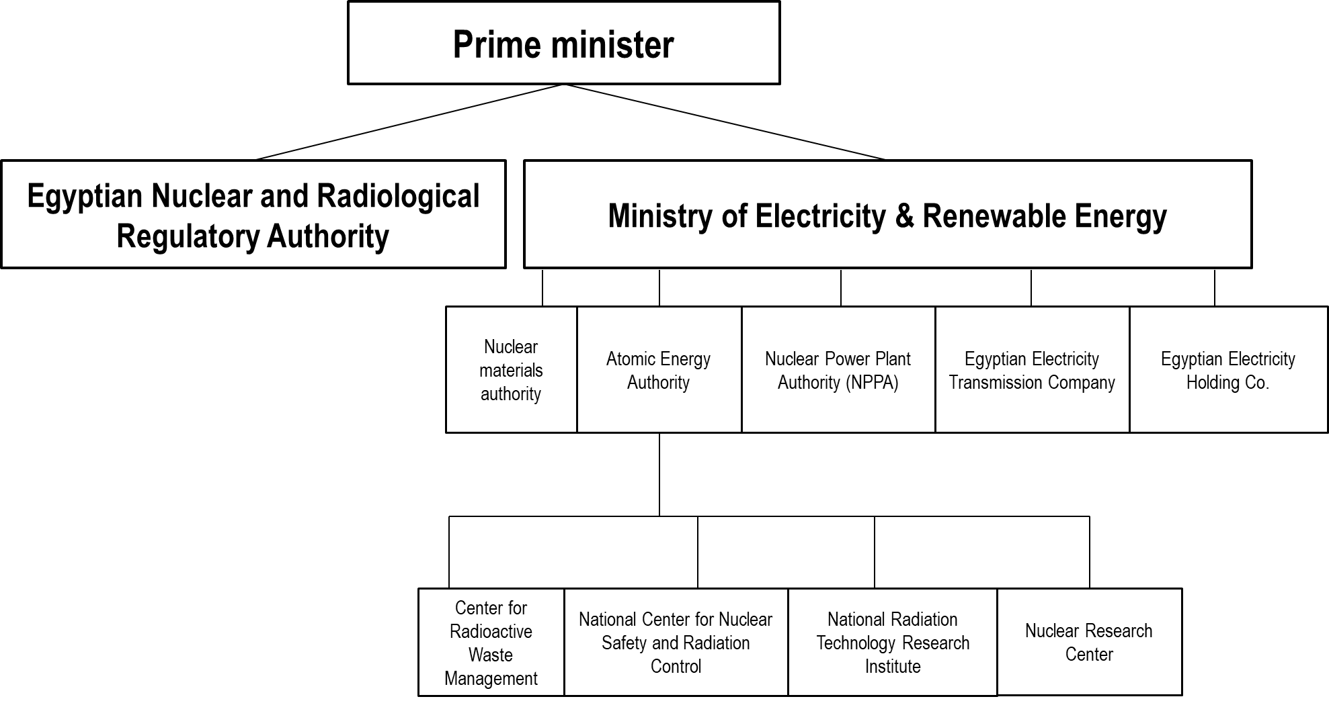

Fig. 6. ARE nuclear industry structure

2.1. Ministry of Electricity and Renewable Energy
Government Resolution of the ARE of 1974 has decided that the goal of the Ministry of Electricity and Renewable Energy is to provide all consumers throughout the country with electric power.

Head: Doctor Mohamed Shaker El-Markabi.

Total number of staff is not given on the website.

Information about job vacancies is not available on the Organization's website.

Functions of the Ministry of Electricity and Renewable Energy:
- optimize the use of available energy sources taking into consideration the environmental protection;
- provide electricity with suitable price and best quality;
- expand utilization of new and renewable energy resources;
- support villages and cities electrification and complete electrifying the urban areas and low population communities;
- interconnect the Egyptian electrical grid to African west and east neighboring countries;
- boost local manufacturing contribution in designing, implementing and manufacturing electrical equipments;
- develop peaceful use of nuclear power;
- restructure electricity sector to optimize investments and improve electrical services;
- utilize modern and advanced technical systems in electricity sector's operations and activities;
- develop the skills of engineers and technicians working in the electricity sector;
- export Egyptian expertise in design, manufacture, negotiation, construction and operation of electrical projects;
take advantage of soft loans & obtain the best terms.

Organizational structure of the Ministry of Electricity and Renewable Energy is given in Appendix No.7 to the Annotation report.

2.2. Nuclear Power Plants Authority (NPPA)

Law No. 210 of 2017 on amendments to the Law on creation of Nuclear Power Plants Authority of Egypt (NPPA) No.13 of 1976 establishes NPPA as an authority responsible for NPP construction and operation for electric power generation and water desalination.
NPPA is responsible for NPP project implementation as well as projects related to it, conduct of respective research and development and training of national staff for nuclear power plants operation and management, creation of joint companies (Article 2 of Law No. 210 of 2017) (section “Training and development of human resources”).
NPPA headquarters is located in Cairo. NPPA owns national scientific staff experienced for successful accomplishment of tasks on NPP projects management in the Arab Republic of Egypt.

NPPA perspective:
Moving of Egypt and its population forward towards better and promising future by means of projects implementation on peaceful use of atomic energy is one of the bases of the national sustainiable development strategy.

NPPA Mission:
- undertaking the implementation of the peaceful nuclear power plant projects in Egypt;
- implementing consecutive t​echnical training programs in order to allow the trainees to acquire the – knowledge and skills required;
- ensuring high professional performance of the selected candidates working at the NPP;
- adopting strict working policies that secure safe operation of the plant taking into consideration the environment and human health;
- addressing all the public concerns with transparency via publications and different media platforms.

Head: Dr. Amged El-Wakeel, Chairman of the NPPA Board of Directors.

Total number of staff is not given on the website.

Information about job vacancies is not available on the Organization's website.

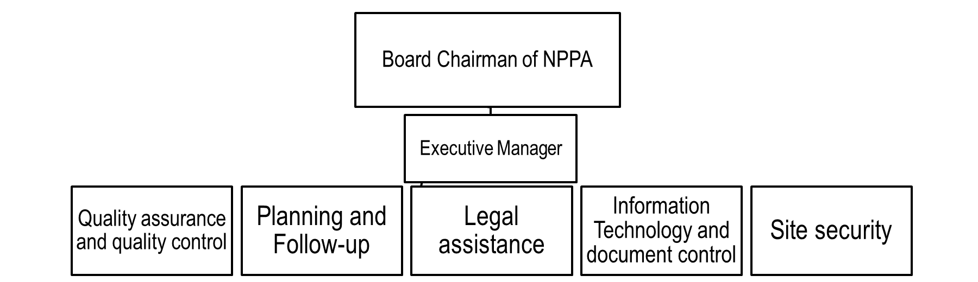
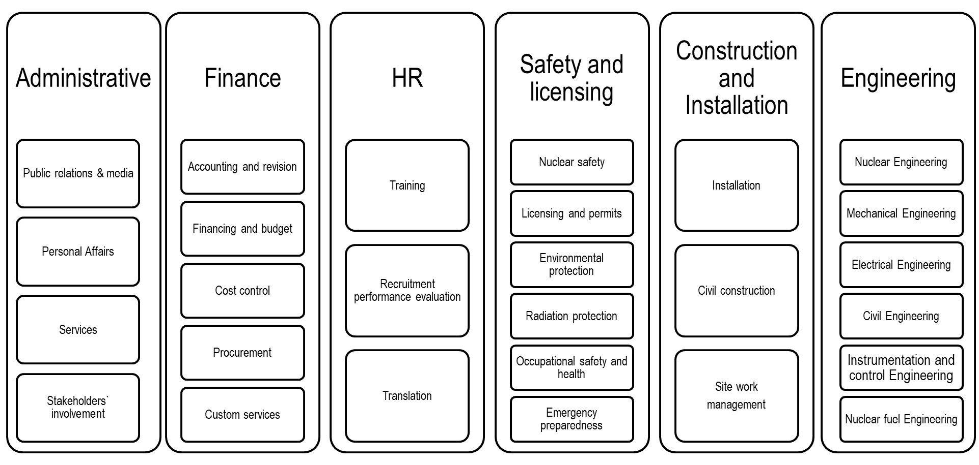
Fig. 7. Organizational Structure of the Nuclear Power Plants Authority of Egypt (NPPA)
Functions of NPPA
According to Art. 3 of the Law No. 7 of 2017 NPPA is in charge for creation, operation and management of nuclear power plants.
NPPA is the exclusive competent authority that carries out activities as follows:
- implementation, operation and management of projects on nuclear power plants construction;
- conclusion of contracts with similar authorities within the country and abroad;
personnel training and qualification within the country and abroad;
- construction of nuclear power plants to generate electric power and desalinate water;
- conduct of research work required for projects on nuclear power plants construction;
- formulation of requirements and technical specifications for projects on nuclear power plants construction.
In 2010 NPPA prepared standard and integrated National strategy on personnel management and development. Information on approval of the document and draft document itself has not been found in resources. Supreme Committee on Education and Occupational Training (SC EOT) was created to integrate human resources development plans of key nuclear industry organizations of the ARE.
INIR Mission was conducted from October 27 until November 6, 2019 in the ARE. In accordance with the Mission Report, ENRRA and NPPA applicants shall be checked prior to employment within the frameworks of Trustworthiness program as a condition for employment. General Intelligence and National Security Service of the country supervise Trustworthiness program. Elements of trustworthiness checks include a review of employment risk, psychological tests, criminal records, drug test, and medical fitness examination for the assigned position.
Trustworthiness program also applies to all contractors which carry our activities in nuclear industry. Moreover, contractors undergo additional checks at previous place of employment, checks for criminal records regarding money laundering and counterfeiting. All workers in the nuclear field are re-checked/re-screened on an annual basis and when promoted to higher positions of responsibility. Trustworthiness examination process takes about 30 business days.

2.3. Egyptian Nuclear and Radiological Regulation Authority (ENRRA)

The Law No.7 of 2010 establishes creation of an independent regulatory authority (ENRRA), subordinate to the Prime Minister of the country, describes authorities and responsibilities of ENRRA.
In March 2012 ENRRA gained status of independent authority by the order of the Prime Minister in accordance with the Law No.7 of 2010, that regulates nuclear and radiation safety. Chairman, Deputy Chairman and ENRRA Governing Council were appointed. In accordance with the law and amendments of 2017 ENRRA management is appointed by the President of Egypt upon presentation of the Prime Minister for a term of four years with the possibility of prolongation for the same period. The Supreme Control Authority of ENRRA - council, council members are also appointed by the President of Egypt upon presentation of the Prime Minister.

ENRRA Mission:
ENRRA has all authorities required for the main regulatory and control functions of the nuclear and radiological activities in order to protect the man, property and environment from deleterious effects of ionizing radiation, as well as safeguards and security.
ENRRA fulfills regulatory and monitoring activities related to nuclear and radiation activities including those to ensure peaceful use of atomic energy, ensure safety and protection of human, property and environment against harmful impact of ionizing radiation.
Head: Dr. Sami Shaaban, Chairman of the Board of Directors.
Total staff number: 51-200 employees.
Information about job vacancies is not available on the Organization's website.
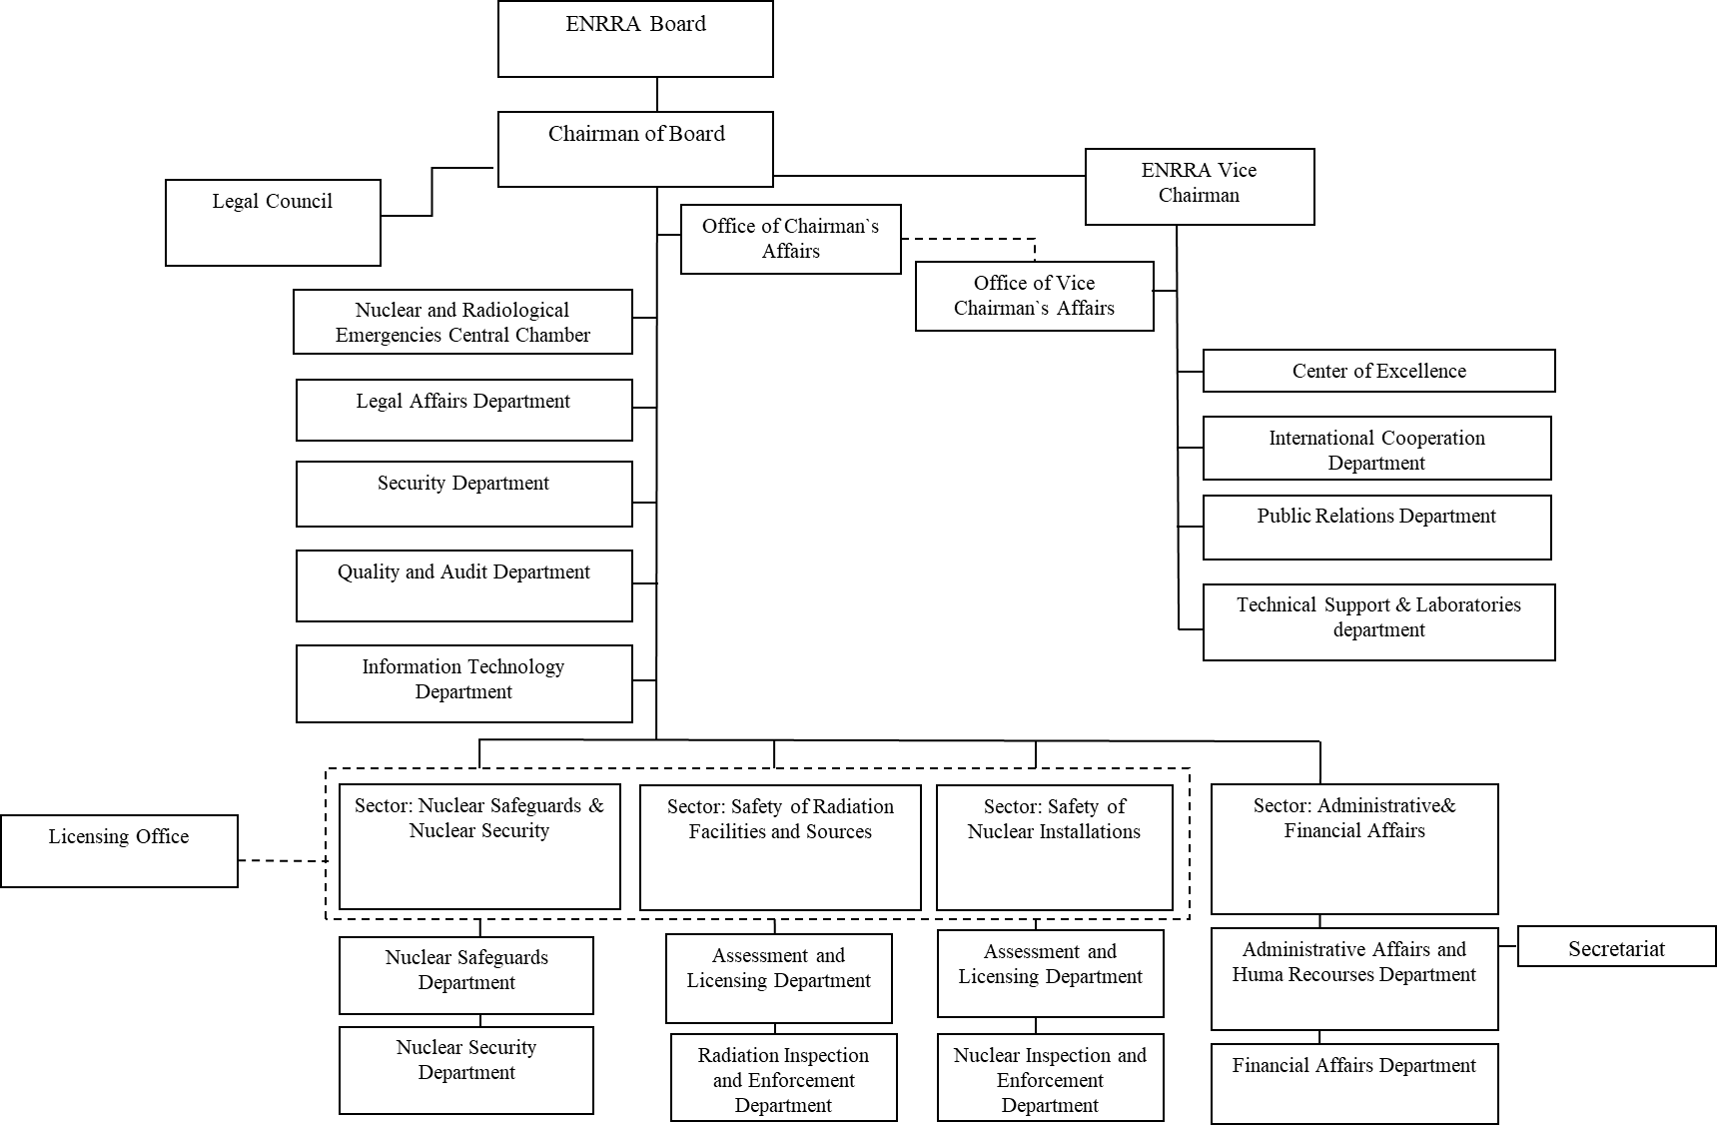

Fig.8. Organization structure of ENRRA

Functions of ENRRA
In accordance with Article 12 of the Law No.7 of 2010, ENRRA is in charge for regulation and monitoring in nuclear safety and physical safety of nuclear facilities, and for licensing as well and fulfills functions as follows:
- issuing, modifying, suspending, renewing, withdrawing and rescinding all types of licenses granted to nuclear or radiation facilities and activities in addition to licenses granted to persons using ionizing radiation, in pursuance of the provisions of the present Law;
- applying administrative closure of places using ionizing radiation in violation of the provisions of the present Law, executive regulations thereof and decrees executing them;
- issuing decrees and rules for licensees- should there be a necessity- to enhance and ensure the safe and secured exercise, without prejudice to the conditions of the granted license;
- obtaining all documents, instruments and information related to its duties from persons in charge of the nuclear or radiation facilities and activities, under its control, without disclosure of the said;
- exercising regulatory and control duties as:
(a) reviewing and assessing safety analysis, including reports presented by the license applicant and issuing resolutions in this regard, as per the systems provided for in this respect;
(b) carrying out regulatory inspection on all nuclear or radioactive exercises at all stages;
(c) setting out rules that regulate the long-term planning of sites handling radioactive wastes and preserving spent nuclear fuel plus exercising control over such sites.
- exercising regulatory and control duties in the field of planning, handling of and preparation for nuclear and radiation emergency cases, as specified in the present Law, executive regulations thereof and decrees executing them;
- heightening public awareness of the regulatory process of the nuclear and radiation activities, developing the means and procedures of their participation, adopting measures necessary for the spread of nuclear security and safety cultures between them and responding to their inquiries on the nuclear or radiation safety status in the area of their residence, unless such information is secretive;
- coordinating with other governmental and non-governmental bodies competent in the work field of the Authority;
- contacting the regulatory and control bodies in foreign countries and international organizations to further cooperation and exchange of regulatory and control duties;
- laying down systems for justified activities, including activities using radioactive sources that enter in radiating food and beverages and in the industry of cosmetics in addition to any other products made for human use;
- developing systems for permissible radiation levels in case of import, obtainment, fabrication or export of any nutritive materials or any other materials for human use;
- inspecting sites at which the products or services in direct relation to safety are supplied, as per the regulations applicable in this regard;
- seeking the opinion and assistance of international and consultancy agencies, technical support organizations, specialized consultancy offices or universities to support and improve its regulatory work, pursuant to the systems applicable in this respect;
- laying down systems to commit operators to conduct nuclear and radiation safety assessments and that includes safety re-assessment processes or periodic safety reviews, throughout the operational lifetime of the nuclear facilities;
- expressing opinion in draft Laws related to the nuclear or radiation activities;
- issuing quarter annually reports on the national radiation status and publishing the same to the public in the Official Gazette, papers and media;
- preparing a report on any violations to the provisions of the present Law and executive regulations thereof;
- conducting researches in relation to the nuclear or radiation safety.

2.4. Potential second priority employers in ARE

A number of energy agencies, commercial companies, non-commercial companies and universities are potential ARE employers for the foreign graduates in nuclear industry. The information is specified in Table 6.

Table 6. List of Egyptian potential second priority employers for foreign students graduating from the Russian universities and trained in nuclear and related specialties
No. | Company | General information | Job vacancies
1 | Nuclear Materials Authority (NMA) | Nuclear Materials Authority was founded in 1977 and has been focused on investigation, search, exploration and production of nuclear materials, as well as nuclear materials processing and extraction from the ores, their production, export or import.  Functions:  • Suggesting state policy and developing plans on researches and investigations related to detection and exploration of nuclear materials, arranging their turnover, as well as organizing comprehensive researches to identify regions with potential use of nuclear materials.  • Training human and scientific resources that specialize in the working fields of the Nuclear Materials Authority. | The job openings are given on the web-site.
2 | Egyptian Environmental Affairs Agency (EEAA) | Foundation date: 1982.  Formulating ecological policy, setting priorities and implementing incentives in the field of sustainable development.  Strategic goal: to embed and integrate ecological aspects into all the national policies, plans and programmes related to human health protection and natural resources management.  Personnel number: 50-100 people. | The job openings are given on the web-site.
3 | Egyptian Electricity Holding Company (EEHC) | Foundation date: 1976.  The company is liable for all aspects of power generation, transmission and distribution in Egypt.  Staffing level: 10 000 people
4 | The Egyptian Electricity Transmission Company (EETC) | Foundation date: 1998.  The company is responsible for all the power plant, transmitting and distributing systems. | The job openings are given on the web-site
5 | El Sewedy Company | Foundation date: 1938.  Mission/functions: to produce and sell power products and services in power segments: power cable, electrical items, telecommunication systems, transformers, to produce wind power, measure and manage energy, design, procure and sign contracts.  Personnel number: 15 000 people | The job openings are given on the web-site.
6 | Power Generation Engineering and Services Company (PGESCO) | Foundation date: 1993.  Mission/Functions:  -manage implementation of electric power facilities;  -draw up technical assignments for electrical and installation works;  -prepare engineering design and detailed plans for all electric power supply systems.
7 | Hassan Allam Holding | Foundation date: 1936.  Hassan Allam Holding is a leading holding in Egypt specializing in design and construction, investment and development. The holding operated in different sectors, including projects related to infrastructure, power industry, water supply, industrial sector, logistics, petrochemical sector and complex large-scale projects in Egypt, as well as the Middle East and Africa.  The holding is put in the list of the 250 best world contractors.  Personnel number: 34 000 people | The job openings are given on the web-site.
8 | ORASCOM Construction | Foundation date: 1950.  The company deals with infrastructural, industrial and high-technology commercial projects launched in the Middle East, in North Africa, in the USA and the Pacific for state and private clients. The company also develops and invests in infrastructural opportunities.  Personnel number: 53 000 people | The job openings are given on the web-site.
9 | Petrojet | Foundation date: 1975.  Leading regional EPC-Contractor in Oil, Gas, Chemical, Petrochemical, Power, Industrial and Infrastructure projects.  Staffing level: 36 000 people | The job openings are given on the web-site.
10 | Arab Contractors Company | Foundation date: 1955.  Specialization: public buildings, bridges, roads, tunnels, airports, housing, water & sewage projects, wastewater treatment plants, power stations, dams, hospitals, sports buildings, restoration of monuments, irrigation, shipbuilding, engineering consultancy, manufacturing and assembly of steel structures, etc.  Staffing level: 60 000 people | The job openings are given on the web-site.
11 | Egyptian-Russian University | The university was founded in 2006.  The Egyptian-Russian University includes the faculties of engineering, pharmacy, oral and dental medicine, as well as management, professional technology and computers.  Engineering courses in the University:  1. telecommunication engineering;  2. mechatronics and robotics;  3. telecommunication engineering;  4. architecture engineering;  5. nuclear power stations engineering. | There are currently no free places at the engineering faculty.  General requirements for the candidates:  - bachelor’s degree in engineering;  - academic performance above average “good”;  - The candidate shall undergo military service or be exempt from the service for life (for men).
12 | University of Alexandria. | Founded in 1942.  Mission of the Faculty of Engineering: train engineering personnel to contribute to process development in the field of nuclear and radiological engineering and peaceful use of atomic energy.  Nuclear engineering is focused on physical and thermal calculation of reactors, material properties test, reactor safety and automated control. | The job openings are given on the web-site.  General requirements for the candidates:  - the appointee shall obey the Universities Organization Law No.44 dd. 1972, amendments to it and its executive instructions.  - candidates that work in the government or the state sector shall submit explicit permission of the employer in order to apply for these positions. 3) Candidate applying for work positions in the College of Veterinary Medicine shall have the degree of Bachelors of Veterinary Medicine.  - have good behavior and reputation  - reside in the Arab Republic of Egypt  - submit application to the name of Mr. Doctor Professor / Vice-president of the University for Matruh branch not later than 15 days from the publication date  - the appointee shall have a doctor’s degree or its equivalent in Egyptian university on subject that entitles the appointee to perform the work or the same degree in any other licensed scientific university in Egypt or abroad accepted as equivalent one by the Universities Supreme Council.  If the candidate have equal capabilities for work, priority is given to the candidates from Matruh province.
13 | El Dabaa Atomic Technical School | The School was founded in 2014. It is a college with 5-year training period.  The School has 3 departments: electric power, mechanics and electronics, the specialized training starts in the 4th grade.  The School teachers undergo training in the Directorate for Nuclear Power within one month. | The Ministry of Education set out several conditions for the candidates:  - the appointee shall have a teaching experience;  - bachelor’s degree in industrial education or continuing education diploma (mechanics, electric power, electronics) for practical subjects teachers;  - have computer skills and know English.
14 | Arab Academy for Science, Technology & Maritime Transport | Regional university managed by the League of Arab States that implements programmes in the field of maritime transport, business and engineering. The Academy was founded in 1972 in Alexandria, Egypt.
15 | Ain Shams University | Ain Shams University is the third Egyptian university and was founded in July, 1950.  Engineering departments related to nuclear industry:  - Power and Electrical Machines Engineering;  - Machines Engineering, Power

3. Qualification requirements

Qualification requirements for employees of nuclear infrastructure organizations
Effective legislative requirements of ARE provide for license issuance to personnel responsible for nuclear power facilities safe and reliable operation.
According to Part 3 of the “Personal licenses for nuclear and radiation activities, Chapter 1 “General rules”, the Decree No. 1326 of the Prime Minister of 2011 “Publication of executive guidelines on application of the Law on management of nuclear and radiation activities, promulgated by the Law No. 7 of 2010”, it is prohibited for a number of personnel categories to carry out nuclear or radiation activities without a license. Personal license for activities causing ionizing radiation can be obtained after receiving a relevant qualification and completing a relevant training according to the training programmes. Any individual having license for use of radioactive sources and substances shall have a bachelor’s degree in a specialized scientific institution and shall have a diploma of radiation physics or a specialized certificate in relevant field issued by an Egyptian educational institution or an equivalent, or shall complete a training programme on use of radioactive sources and substances. Such individual shall prove that he/her has completed sufficient training in programmes on use of radioactive sources and substances and protection against them organized by any organization implementing such programmes.
A list of licensed positions is specified, along with the requirements for the qualification, work experience and medical examination of the licensed personnel, namely:
- operators of nuclear and radiation facilities having licensed for such facilities operation,
- experts at issues related to protection against radiation hazards,
- employees and experts at radiological protection,
- users of radiation sources and radioactive materials,
- doctors using radiation sources and radioactive materials for diagnostics and treatment,
- engineering radiologists using radiation sources and radioactive materials,
- assistants of engineering radiologists working with radiation sources and radioactive materials.
Simplified requirements for training level are provided for personnel of new nuclear facilities.
Qualification requirements for different specialists for NEP are publicly unavailable.

