People's Republic of Bangladesh (PRB)

1. Description of the Rooppur NPP construction project
Cooperation between the People's Republic of Bangladesh (PRB) and the Russian Federation in the field of nuclear energy is based on the intergovernmental agreement on the Rooppur NPP construction, signed in Dhaka in November 2011, and the general contract for the Rooppur NPP construction dated December 25, 2015.
PRB uses nuclear energy in the form of operation of research reactor and ionizing radiation sources in different areas of economy, as well as researches. However, the existing legislative and regulatory framework, the technical equipment of nuclear energy programme (NEP) organizations, as well as the experience and human resources for nuclear facilities existing in PRB are insufficient for the construction and operation of NPP and require improvement, as well as timely development of the PRB human resources.
According to Article 6 of the Agreement between the Government of the Russian Federation and the Government of the People's Republic of Bangladesh on cooperation in the construction of NPP on the territory of the People's Republic of Bangladesh dated November 2, 2011, the Russian side provides training for the personnel of the Bangladeshi side for the construction and operation of the Rooppur NPP.
From 2012 to 2019, under the quotas of the Ministry of Science and Higher Education of the Russian Federation, foreign citizens from the PRB were selected for subsequent training at Russian universities in nuclear and related specialties and practical work at the Rooppur NPP.
As of February 2022, 22 students from Bangladesh study at Russian universities in nuclear areas under quotas of the Rosatom State Corporation: NRNU MEPhI (Moscow), NRNU MEPhI (Obninsk), FSAEI HE NR TPU (Tomsk), under the specialist program “Nuclear power plants: design, operation and engineering”.
Since 2019, the recruitment of Bangladeshi students for training under quotas to specialized universities-partners of the Rosatom State Corporation has been suspended due to the lack of recruitment needs on the part of the Foreign Customer represented by the Bangladesh Atomic Energy Commission.
Mechanisms for employment of Bangladeshi graduates who studied under the quotas of the Ministry of Education and Science of the Russian Federation through the Rosatom State Corporation do not function on a systematic basis, not all graduates can find a job after graduation, even possessing diploma with honors.

2. Key organizations of the nuclear infrastructure of Bangladesh
Within the structure of the PRB nuclear industry, the first priority employers’ organizations include the Ministry of science and technology of the PRB (hereinafter - MOST), the Bangladesh Atomic Energy Commission (hereinafter - BAEC) and the Bangladesh Atomic Energy Regulatory Authority (hereinafter - BAERA). Figure 1 shows a top-level diagram of the PRB nuclear industry.
MOST supervises and coordinates the implementation of the PRB nuclear energy programme. The overall activity of the Rooppur NPP project is carried out by BAEC, which, in turn, has its own research institutes and laboratories. Nuclear Power Plant Company Bangladesh Limited (NPCBL) is the operating organization of Rooppur NPP. BAERA acts as an independent nuclear regulatory authority and is accountable to MOST.
In 2010, the PRB government adopted a National Action Plan (BANPAP) for the nuclear energy development, which presumably includes a section on human resource development, but BANPAP is not publicly available.

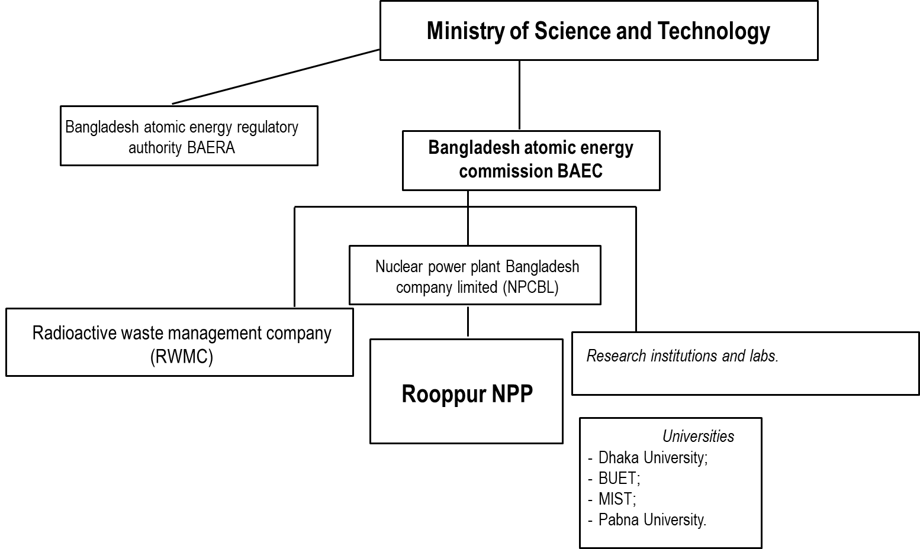
Fig. 1. PRB nuclear industry structure
In addition to the first priority employers, the recruitment needs for the second priority employers shall be highlighted. Table 2 shows different categories of personnel required by the Rooppur NPP project under the National Nuclear and Radiological Emergency Preparedness and Response Plan.

Table 2. Potential employers under the National Nuclear and Radiological Emergency Preparedness and Response Plan.
№ | Personnel category in accordance with the Rooppur National Emergency Plan | Quantity of pers.
1 | Personnel of organizations and ministries providing radiation protection (MOST, BAEС, BAERA, NPCBL, Ministry of Environment, Forest and Climate Change, Ministry of Defense, Ministry of Disaster Management and Relief, Ministry of Foreign Affairs, Ministry of Public Administration, District Administration, National Nuclear and Radiological Emergency Management, Ministry of Local Government, Ministry of Water Resources, Ministry of Agriculture, Ministry of Finance, Ministry of Fisheries and Livestock and etc.) |  | ≤1000
2 | Personnel of organizations of the country's electric power system (Ministry of Power, Energy and Mineral Resources, Bangladesh Energy Regulatory Commission, Power Grid Company of Bangladesh, Bangladesh Power Development Board, Sustainable and Renewable Energy Development Authority and etc.) |  | ≤100
3 | Personnel of organizations and ministries providing emergency preparedness and response, municipals authorities (MOST, BAERA, BAEC, NPCBL, National Nuclear and Radiological Emergency Management Centre, District Administration, Ministry of Disaster Management and Relief, Ministry of Foreign Affairs; Ministry of Public Administration, Ministry of Defence, Ministry of Local Government, Rural Development and Cooperatives, Ministry of Housing and Public Work, Ministry of Information, Ministry of Power, Energy and Mineral Resources, Ministry of Agriculture, Ministry of Food, Ministry of Finance, Ministry of Environment and Forests, Ministry of Road Transport and Bridges, Ministry of Railways, Ministry of Home Affairs, Ministry of Civil Aviation and Tourism, Ministry of Water Resources, Ministry of Posts, Telecommunications and Information Technology, Ministry of Commerce, Ministry of Law, Justice and Parliament Affairs,etc.) |  | ≤1000
4 | Personnel of organizations and ministries providing physical protection of nuclear material, nuclear installations and nuclear material, radioactive waste and spent nuclear fuel storage facilities and transportation (MOST, BAEС, NPCBL, BAERA, Bangladesh Army, Ministry of Disaster Management and Relief, etc.) |  | ≤250
5 | Personnel of organizations and ministries providing nuclear material accounting and control, IAEA safeguards application, export control (MOST, BAEC, BAERA, NPCBL, Ministry of Foreign Affairs, Ministry of Home Affairs, Ministry of Finance, Bangladesh Customs, Ministry of Law, Justice and Parliament Affairs, etc.) |  | ≤60
6 | Personnel of organizations and ministries providing radioactive waste management (MOST, BAEС, BAERA, NPCBL, Ministry of Environment, Forest and Climate Change, RWMC, Ministry of Disaster Management and Relief, etc.) |  | ≤100

2.1. Ministry of science and technology of the PRB (MOST)
The Ministry of science and technology coordinates scientific and technical activities and the development of nuclear energy in Bangladesh. The Ministry was founded in 1983.
Mission of the Ministry:
to support the achievement of the country's social and economic development through research, development, peaceful use of nuclear energy, including nuclear energy generation, expansion and successful use of science and technology.

Head: Architect Yafesh Osman, Minister of Science and Technology of the PRB.
Total number of staff: not specified, provided by managerial positions at the official website of the Ministry.
Organizational structure of the Ministry of science and technology of the PRB

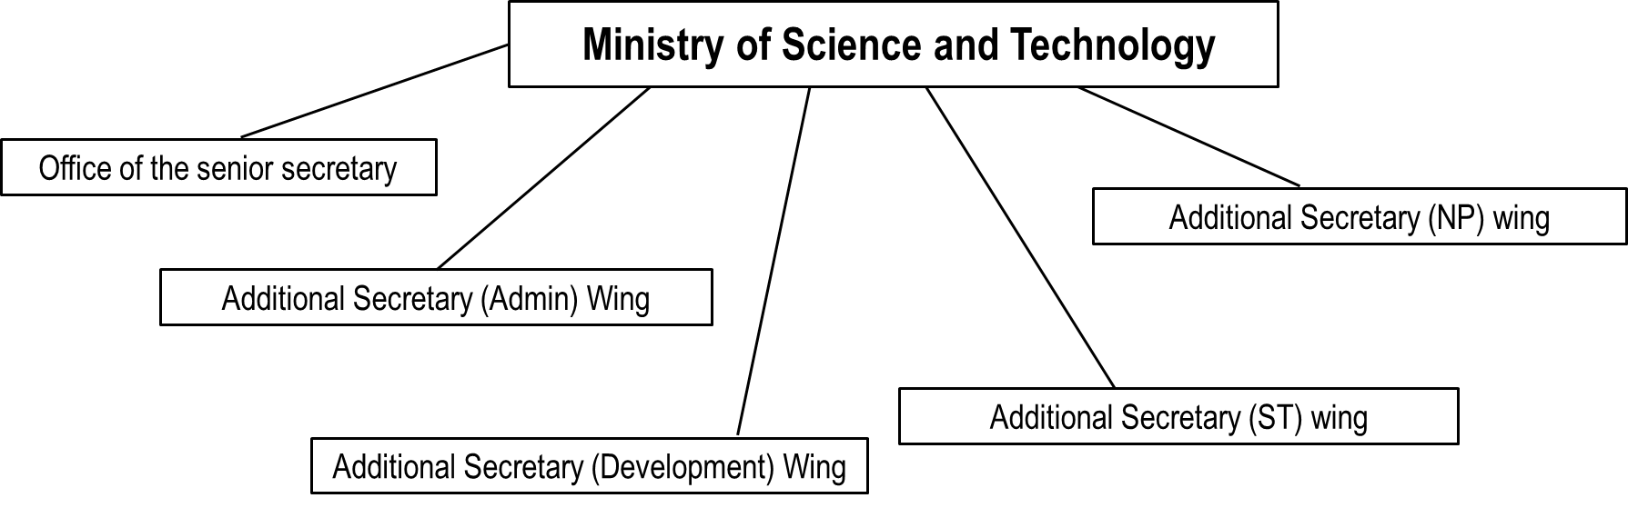

Fig. 2. Structure of the Ministry of science and technology

Main functions of the Ministry of science and technology:
- development and review of national science and technology policy in accordance with national goals and plans;
- scientific and technical research, development and coordination between the participants of the activity;
- regulation and development of nuclear energy, as well as power generation at NPP (including integration into the national power grid).

MOST undertakes efforts to develop a National Human Resources Development Plan, which includes suggestions for the development of the national education system. To develop this suggestions, the system of higher and secondary vocational education in Bangladesh was assessed and BAEC has also established cooperation with a number of leading Bangladeshi universities. The approved Comprehensive Personnel Training and Continuous Education Plan for the PRB nuclear energy programme is not publicly available.

2.2. Bangladesh Atomic Energy Commission (BAEC)

The Bangladesh Atomic Energy Commission (BAEC) is a government entity established by the President’s Order No. 15 of February 1973. It is responsible for the promotion and development of the peaceful uses of atomic energy and the development of nuclear energy.

BAEC mission:
- peaceful use of atomic energy;
- socio-economic development of the country;
- progress in nuclear science and technology.

Head: Md Azizul Haque, from February 23, 2022.
Total number of staff is not specified on the website.

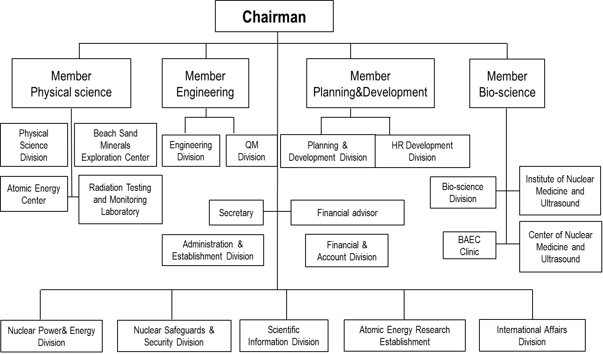
Fig. 3. Organizational structure of BAEC

BAEC functions, according to it.10 of the Bangladesh Atomic Energy Commission Order, 1973 (as amended in 2017):
- implementation of nuclear energy programme;
- application of nuclear technologies in agriculture, industry, health and the environment;
- development of human resources in nuclear science and technology;
- introduction of radiation safety culture.

Information about vacancies is available on the BAEC website.
In accordance with the organizational structure (Fig. 2), BAEC has a Human Resources Department responsible for development and training of the Rooppur NPP personnel.
There are research institutes and laboratories within the BAEC that have the potential to be second priority employers for Bangladeshi graduates, detailed information is shown in Table 3.

Table 3. BAEC research institutes and laboratories
No. | Name | Organization mission and functions | Staffing level: | Organization subdivisions
1. | Atomic Energy Research Establishment | Training of qualified researchers in atomic energy | 200 researchers and 366 employees | - Central Administration & Establishment Division;  - Central Finance & Accounts Division;  - AERE Medical Clinic
2 | Institute of Nuclear Science and Technology | Development of an overall capability in the field of PRB nuclear reactor science and technology. | 70 workers - research personnel, 90 workers - supporting personnel | - Reactor and Neutron Physics Division;  - Reactor Physics and Engineering Division;  - Reactor Engineering and Control Division;  - Radioisotope Production Division;  - Nuclear and Radiation Chemistry Division;  - Isotope Hydrology Division;  - Health Physics and Radioactive Waste Management Unit;  - Tandem Accelerator Facilities Division.
3 | Institute of Computer Science | Undertaking of R&D programmes in the area of information and communication technology (ICT) and provision of ICT related services to BAEC and other organizations. | 14 workers. | - Software Engineering Division;  - Nuclear Cyber Security Division;  - Computer System and Networking Division.
4 | Institute of Electronics | Development and application of sustainable technology in the field of Electronics. | 22 workers | - General Electronics Division;  - Medical Instrumentation Division;  - Nuclear Electronics Division;  - Production Division;  - Repair and Maintenance Division;  - Solar Cell Fabrication and Research Division;  - Center of Excellence for VLSI Technology.
5 | Institute of Nuclear Medical Physics | Provision of advanced training in order to develop qualified medical physicists and nuclear medical technologists. | 45 workers, including physicists, physicians, technologists, chemists, and engineers. | - Radiotherapy and Patient Services Division;  - Nuclear Medicine Division;  - Diagnostic Radiology Division;  - Dosimetry Division;  - PET/CT Instrumentation & Management Division;  - Cyclotron Division;  - Research & Training Division.
6 | Institute of Energy Science | Building of trained and skilled manpower in different areas related to energy production, promotion of R&D activities in the respective fields, etc. | 3 workers.
7 | Training Institute | Arrangement of Basic Nuclear Orientation Course as basic training of the newly recruited scientists in the fields of Physical, Biological and Engineering sciences during their probationary period, etc. | The Institute's website lists only the Director and Security Director, Dr. Ananda Kumar Das.
8 | Scientific Information Unit | Provision of necessary scientific information and documentation to the researchers of the Atomic Energy Research Establishment. | The Unit's website lists the Director and Security Director, Dr. Swapan Kumar Chakraborty.

2.3. Nuclear Power Plant Company Bangladesh Limited (NPCBL)

The company was established under the NPP Act of September 8, 2015 and is intended to be the operating organization of the Rooppur NPP.
Head: Dr. Shawkat Akbar, director of the Rooppur NPP project.
Total number of staff: under formation. The official website of the Organization specified 54 workers.
Information about vacancies is available on the Organization's website.
In particular, the most recent NPCBL vacancies include those for Manager/Deputy Manager/Senior Assistant Manager Positions (see Table 4).

Table 4. Job Circular of NPCBL.
No. | Position | Required level of academic qualification | Minimum experience
1 | Manager (Licensing & Regulatory Compliance) | MSc/ BSc (4 years) Degree in Physics or Nuclear Engineering or BSc Engineering Degree in any subject from any PRB Government & UGC recognized university (UGC - University Grants Committee). | 10 (ten) years of experience in Licensing & Regulatory Compliance
2 | Deputy Director (IT & Communication) | MSc/ BSc (4 years) Degree in Applied Physics & Electronics or BSc Engineering Degree in Electrical and Electronics Engineering/ Electronic and Telecommunication Engineering/ Electronics and Communication Engineering/ Information and Communication Engineering/ Information Technology/ Computer Science & Engineering from any PRB Government & UGC recognized university. | 7 (seven) years of experience in the fields of IT & Telecommunication, including 2 (two) years of experience as Senior Assistant Manager or equivalent position
3 | Deputy Manager (Licensing & Regulatory Compliance) | MSc/ BSc (4 years) Degree in Physics or Nuclear Engineering or BSc Engineering Degree from any PRB Government & UGC recognized university. | 7 (seven) years of experience in Licensing & Regulatory Compliance
4 | Senior Assistant Manager (Quality Management) | MSc/ BSc (4 years) Degree in Nuclear Engineering or BSc Engineering Degree in Mechanical Engineering from any PRB Government & UGC recognized university. | 4 (four) years of experience in relevant fields in Nuclear R&D Organization
5 | Senior Assistant Manager (Modernization & Equipment Life Cycle Management) | MSc/ BSc (4 years) Degree in Nuclear Engineering or BSc Engineering Degree in Mechanical Engineering from any PRB Government & UGC recognized university. | 4 (four) years of experience in relevant fields in Nuclear R&D Organization/ NPP or in Combined Cycle or Steam Turbine Power Plants operation & maintenance.
6 | Senior Assistant Manager (Inspection & Violation Investigation) | BSc Engineering Degree in Mechanical Engineering from any PRB Government & UGC recognized university. | 4 (four) years of experience in Inspection or Operation in Nuclear R&D Organizations.
7 | Senior Assistant Manager  (Fire Safety) | BSc Engineering Degree in Mechanical Engineering from any PRB Government & UGC recognized university. | 4 (four) years of experience in Fire Protection and Industrial Safety in any reputed organizations
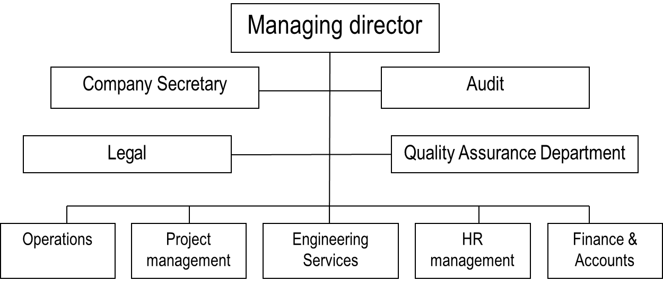

Fig. 4. Draft Organogram of NPCBL
The detailed organizational structure of NPCBL is given in Appendix No. 6 to the Annotation Report.

Main functions of NPCBL:
Art. 7.5 of Nuclear Power Plant Act of 2015 provides the following functionality:
- engaging of services and maintenance for NPP operation;
- periodic inspections and monitoring of project management activities in order to ensure NPP safe operation;
- repeated monitoring and audits to ensure that the NPP project personnel is aware of safety;
- coordination with the IAEA and other international organizations for effective project implementation and safe NPP management, taking into account the IAEA requirements and international practices;
- hiring, training and advanced training of employees to improve the efficiency of NPP duties performance;
- upon completion of NPP construction - NPP commissioning;
- timely maintenance of important NPP components, testing, supervision and inspection activities;
- development of site definition plan, decommissioning design at NPP construction stage;
- improvement of NPP safe management system and nuclear safety measures in accordance with the IAEA standards;
- adoption and development of radiation protection measures to ensure the protection of employees, the public and the environment against the harmful effects of radiation;
- improvement of the standardization process to ensure a modern organizational structure, effective commitments, in the process, management, execution, assessment and improvement;
- creation of a radioactive waste management system to ensure the management of spent nuclear fuel, its disposal and recycling;
- measures to prevent emergencies occurring at NPP and development of emergency preparedness procedures;
- performing other tasks as defined in the organization's charter.

The question of which organization will issue the license to operate the Rooppur NPP remains open. Previously, all licenses were issued by BAEC, the operational personnel currently undergoing training for the position are also employed by BAEC.

2.4. Bangladesh Atomic Energy Regulatory Authority (BAERA)

In 2012, the PRB Government issued the Atomic Energy Regulatory Act (BAERA Act No. 19) establishing an independent regulatory authority, the Bangladesh Atomic Energy Regulatory Authority (BAERA).
It was created in 2012 according to the BAERA Act No. 19.
BAERA mission:
Proper compliance with nuclear control programmes related to safety, security, radiation protection and safeguards to protect the life and health of the population and workers, as well as to monitor adverse reactions in the environment.

Head: Engineer Md. Musammel Haque.
Total number of staff is not given on the website.
In compliance with National Report of the PRB for the Eight’s Review Meeting under the Convention on Nuclear Safety procedure, BAERA has planned to employ 360 employees to the Organization’s staff to fulfill their functions for the Rooppur NPP. In accordance with it. 6.1.2. of the National Report of Bangladesh for the Eight’s Review Meeting under the Convention on Nuclear Safety procedure and BAERA Act of 2012, in compliance with GSR Part-1 requirements, BAERA obligations include human resources development.
BAERA functions in accordance with Art. 11 of the BAERA Act of 2012 :
- to ensure whether safe and peaceful use of atomic energy is complied with or not in accordance with the provisions of the BAERA Act or rules and regulations made thereunder;
- to make and enforce necessary standards, codes and manuals;
- to give approval of all activities specified in section 18, that is to issue licence, certificate, registration, permit etc. and to amend, suspend or cancel thereof;
- acts to ensure whether all the provisions specified in section 18 relating to nuclear safety, radiation protection, security, safeguards, control of import and export, and physical protection are properly complied with or not;
- to develop a system or process for review and assessment of regulatory activities;
- to take initiative and implement programmes for conducting inspection;
- to carry out review and assessment, inspection, and issuance of licence;
- to formulate guidelines for the purpose of enforceable activities and take actions against noncompliance of this Act and rules or regulations made thereunder and to continue it;
- to determine matters for exclusion;
- to determine and grant exemptions to any facility or nuclear installation from regulatory control;
- to determine obligations, including financial matters of authorized persons or entities;
- to determine the limits of radioactivity in soil, water and air or any article of food used for human beings and animals or used otherwise;
- to organize public participatory activities through seminar, workshop, electronic and print media and internet, etc. for information and consultations with interested parties regarding the possible risks associated with facilities and activities;
- to participate for determining the definition of the design basis threat for the implementation of security measures;
- to make and maintain a national register for radiation sources and to update it regularly;
- to make and maintain a national register and update it regularly for persons authorized for carrying out the activities or practices under this Act or rules or regulations made thereunder;
- to discharge duties as an organizer and a co-ordinator for implementing Safeguards Agreements;
- to conduct activities relating to the implementation of international contracts, agreements, protocols and convention (in which Bangladesh is a contracting party) on safeguards and physical protection including illicit trafficking of nuclear and radioactive materials, nuclear safety, radiation protection and radiological emergency situation;
- to make and maintain a state system of accounts and control of nuclear material;
- to conduct research on regulatory matters;
- to communicate and to co-ordinate with various government or non-government bodies having competence in the area of health and safety, environmental protection, security and transport of dangerous goods;
- to formulate national nuclear and radiological emergency planning and to discharge all duties as a co-ordinator in this regard;
- to approve an effective reporting procedures in respect to radiation incidents and to ensure whether plans for nuclear and radiological emergency preparedness and protective actions have been prepared or not in nuclear and radiological emergency situation;
- to ensure that appropriate measures for physical protection of nuclear and radioactive materials and nuclear installations are taken;
- to detect unauthorized or malicious activities against nuclear or radioactive materials and related facilities including protection and response to them, and establish regulatory control system on such materials or facilities mentioned above;
- to ensure that corrective actions are undertaken when unsafe or potentially unsafe conditions are detected concerning nuclear installations, radiation generator, nuclear material, nuclear substance or radioactive material;
- to determine the liabilities and circumference of nuclear damage and operate the activities relating thereto;
- to communicate and co-operate with any foreign regulatory bodies, international organizations or agencies concerning nuclear safety and radiation protection;
- to determine the terms and conditions of appointment and the services of the employees;
- to take initiative and to conduct human resources development and training programmes for its employees;
- to exchange regulatory information and expand co-operation with regulatory bodies of different countries and international organizations or agencies;
- to publish relevant information and to communicate with the relevant agencies, public and media;
- to take initiative for creating awareness among the public concerning nuclear safety and radiation protection;
- to make schedules for fees and charges;
- to formulate necessary policies and issue orders and to implement thereof in areas of its responsibility;
(36) to perform any other duties prescribed or assigned to the Authority by rules or regulations or by Government, from time to time.

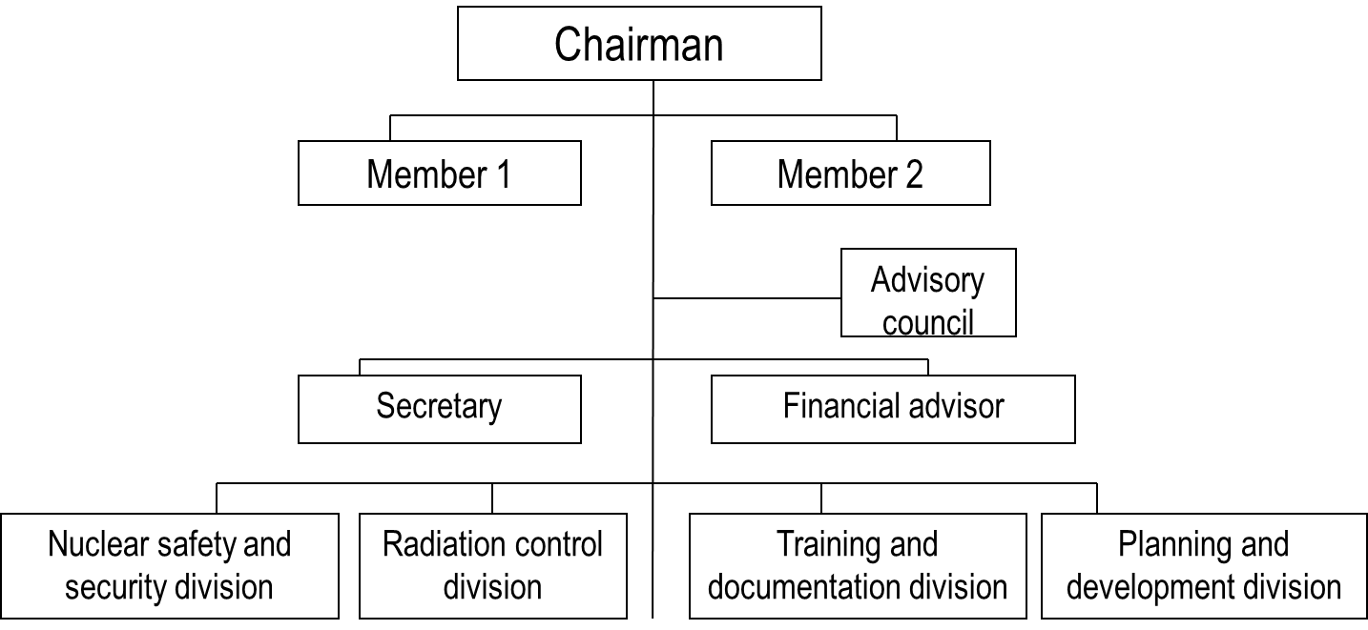
Fig. 5. Organizational Structure of BAERA

Information about vacancies is available on the Organization's website. In particular, job vacancy of Senior Engineer is available (Nuclear Power Engineering). Requirements for applicant:
• candidate of sciences in nuclear engineering at any recognized university or
• master’s degree in nuclear engineering at any recognized university with work experience of at least 3 (three) years in the relevant field or
• master’s degree in nuclear engineering at any University recognized by PRB Government with work experience of at least 4 years in the relevant field.

2.5. Radioactive Wastes Handling Company
No organization created. No information available.

2.6. Potential second priority employers
Army of Bangladesh under the aegis of the Ministry of Defence of the PRB and universities emply the potential PRB employers for the foreign graduates in nuclear industry. The information is provided in Table 5. Considering that the industry is relatively new, there is a need for the human resources development in research and educational institutions and scientific personnel that are involved in future specialists training.
PRB army has concluded the contract with Russian organization of the “FCS&HT “SNPO “Eleron” JSC in terms of assistance to the Bangladesh side for creating physical protection system at Rooppur NPP within the protocol dated September 18, 2018 to the Agreement between the Government of the Russian Federation and the Government of the People’s Republic of Bangladesh on cooperation in the construction of nuclear power plant on the territory of the People’s Republic of Bangladesh dated November 2, 2011.
Table No. 5 Potential second priority employers.
No. | University | General information | Job vacancies
1 | Army of Bangladesh | Army of Bangladesh is a subdivision subordinate to the Ministry of Defence of the PRB.  The Mission of the Ministry is to maintain country's sovereignty by means of improving capacity and efficiency of other authorities, including Military Forces and defence. | Job vacancies are not available on the official website of the Ministry.
2. | Dhaka University: Nuclear engineering faculty | Nuclear engineering faculty; currently this faculty offers Bachelor's, Master’s and Post Graduates programmes (to gain higher doctorate degree). | Job vacancies available on the web-site of the University :  Qualification requirements for the lecturer:  Applicants shall gain diplomas with honors and receive Master’s degree in nuclear engineering at any university. Applicants shall have academic records of at least 3.50 of 4.00 GPA in both diplomas with honors and Master’s Degree course and shall have grades of at least 4.25 from 5.00 GPA at entrance examination.  Preference can be given to those with a higher academic degree. Conditions for internal applicants can be moderated.
3. | Bangladesh University for Engineering and Technology | The university was founded in 1876, it includes nuclear profile departments. Nuclear Power Engineering Institute, in particular. The institute was founded in September, 2015 with the aim to maintain and promote the first nuclear power engineering project in the country. | Job vacancies: 2 positions of Senior Lecturers.
4. | Military Institute for Science and Technologies | The Institute was founded April 19, 1998 by Prime Minister Sheikh Hasina.  Department of Nuclear Science and Technology was founded in 2014 among specialized department of nuclear industry.  Mission:  to promote knowledge and training in nuclear science and engineering by means of high-quality education and researches. | Job vacancies as of January, 2021:  Applicants are invited for the following positions at nuclear science and technologies faculty:  Senior Lecturer  Required qualification:  Master/Candidate of Science in nuclear science and engineering/ nuclear technologies/ mechanic engineering of any state/ foreign university.  Teacher  Required qualification:  Bachelor’s degree in nuclear technologies with minimum grade of 3.60 from 4.00 GPA at any state university. The priority will be given to Master’s degree in nuclear engineering at any recognized university.
5. | Pabna University of Science and Technology | The university was founded June 5, 2008.  There is no separate nuclear industry faculty in the University. Physical faculty in the University includes some major nuclear industry subjects, but there is no specialized department yet. | Not given.

3. Qualification requirements

Qualification requirements for employees of nuclear infrastructure organizations
In accordance with the for the PRB Nuclear Infrastructure Assessment Report of 2020, qualification requirements to education and employment period are established for nuclear industry employees, who shall gain the license for the right to be employed in the field of atomic energy use, the list of the necessary competencies for licensed positions shall be approved as well. The list of positions of NPP employees, who shall gain BAERA permits for the right to carry out work in the field of atomic energy use, has been established by BAERA as agreed upon with the relevant key stakeholders of the PRB. Part of qualification requirements for operational personnel has been recorded in Art. 13 of the Nuclear Safety & Radiation Control Rules – 1997. Requirements to general criteria (both physical and physiological) for key NPP personnel are listed hereinafter:
- NPP shall be staffed with personnel having the required qualification and having been authorized for individual work in the prescribed manner before nuclear fuel supply to the plant;
- operating personnel is authorized to carry out certain work when the permit (license from the reactor operator) issued by BAERA is available;
- BAERA shall make the list of positions of NPP employees who shall obtain the permit from BAERA for the right to carry out work in the field of atomic energy use, as agreed upon with the relevant parties;
- qualification requirements to personnel, who obtain permits/licenses under the list of positions, shall be specified by Operating organization in qualification guidelines for positions of managers and specialists, shall be agreed upon with BAERA and other interested authorities of the PRB;
- qualification requirements to other NPP personnel are specified by NPP operating organization;
- NPP operating organization shall ensure the relevant recruitment, training, authorization to independent work and support of qualification level of operational personnel. The system for recruitment and training of NPP operational personnel shall be aimed at reaching, monitoring and supporting of its qualification level, required to ensure NPP safe operation in all modes, as well as at fulfilling of arrangements aimed at elimination of consequences of accidents occurred.
Part of general qualification requirements to BAERA personnel are given in BAERA Code of Ethics dated 2018. In particular, clause 3 of the document describes competencies which organization’s employee shall gain: required knowledge, possibilities and skills to accomplish tasks effectively.

